SENIOR SIX TERM 3 PHYSICS 2026
TOPIC 1/3: ATOMIC PARTICLES
Competency: The learner appreciates the structure of the atom and how the components of the atom are applied in different devices.

Dalton's Atomic Theory(1803–1808)
John Dalton proposed his atomic theory in the early 19th century, laying the foundation for modern chemistry and physics. Though some points have been modified with later discoveries of subatomic particles and isotopes, his core ideas remain fundamental to our understanding of matter.
Key Postulates:
- All matter is composed of atoms: Matter, whether an element, compound, or mixture, is made up of extremely small, discrete particles called atoms.
- Atoms are indivisible and indestructible: Dalton proposed that atoms cannot be subdivided, created, or destroyed.
- Atoms of the same element are identical: All atoms of a specific element are the same in terms of mass, size, and properties. Atoms of different elements have different masses and properties.
- Atoms combine in simple whole-number ratios: Compounds are formed when atoms of different elements join together in fixed, simple, whole-number ratios (e.g., H₂O, not H₂.₅O).
- Atoms are rearranged in chemical reactions: Chemical reactions involve the separation, combination, or rearrangement of atoms; the atoms themselves are not changed into atoms of another element during the process.

Subatomic Particles and Their Properties
Contrary to Dalton's original idea, atoms are divisible and are composed of even smaller subatomic particles: protons, neutrons, and electrons and isotopes show atoms of the same element can differ in mass
Particle | Location | Charge | Relative Mass (approx.)
Proton | Nucleus (center) | Positive (+1) | 1 atomic mass unit (amu)
Neutron | Nucleus (center) | Neutral (0) | 1 atomic mass unit (amu)
Electron | Electron cloud (orbiting the nucleus) | Negative (-1) | ~0 (about 1/2000 of a proton/neutron)
Key Properties:
- Nucleus: Protons and neutrons are packed tightly in the dense, central nucleus, which contains almost all of the atom's mass.
- Electrons: Electrons orbit the nucleus in an "electron cloud" or specific energy levels/shells. They are held in orbit by the electromagnetic force of attraction to the positive nucleus.
- Charge Neutrality: A typical, neutral atom has an equal number of protons and electrons, which balances the positive and negative charges to an overall charge of zero.
- Atomic Identity: The number of protons determines the element's atomic number and identity (e.g., all carbon atoms have 6 protons).
- Empty Space: Most of the atom's volume is empty space; the nucleus is extremely small compared to the overall size of the atom.
- Atoms of the same element with the same number of protons but different number of neutrons are called isotopes.

Thomson’s plum pudding atomic structure model

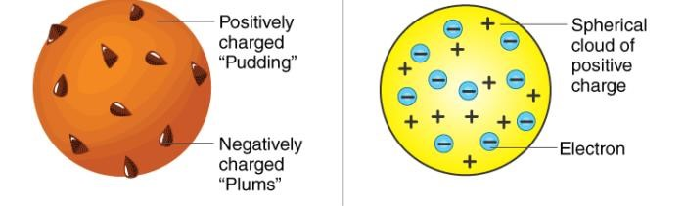
Thomson's Plum Pudding Model (1904) proposed the atom as a sphere of uniform positive charge (the "pudding") with negatively charged electrons (the "plums") embedded within it, like raisins in a cake, to explain the atom's neutrality after discovering the electron. It suggested electrons were scattered in a diffuse positive cloud, but this model was later disproven by Rutherford's gold foil experiment, which revealed a dense, positive nucleus.
Key features of the model:
- Positive Sphere: The atom was a solid, positive sphere or "soup".
- Embedded Electrons: Tiny, negative electrons were scattered throughout this positive mass.
- Neutral Atom: The total negative charge of the electrons balanced the positive charge, making the atom neutral.
Significance:
- It was an important early attempt to incorporate the newly discovered electron into an atomic structure.
- It paved the way for future models, eventually being replaced by Rutherford's nuclear model, which introduced the nucleus.

Rutherford’s Scattering Experiment & Observations

Procedure
- Alpha particle source: A radioactive material (like radium) emitted α-particles.
- Gold foil target: A very thin sheet of gold (about 100 nm thick) was used.
- Detection screen: A fluorescent screen coated with zinc sulfide surrounded the foil to detect scattered α-particles.

Method
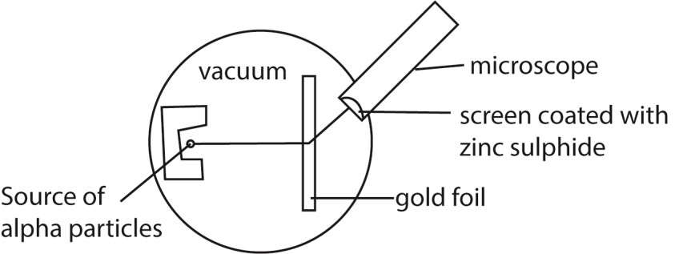
- α-particles were directed at the gold foil.
- Their scattering patterns were observed as flashes of light on the screen.
- It was carried out in a darkened room so that the scintillations can be seen clearly and the apparatus is evacuated to ensure that the particles are able to reach the screen without losing energy.

Observations
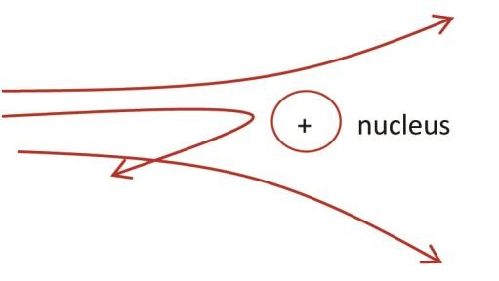
- Most α-particles passed straight through the foil without deflection. • Some α-particles were deflected at small angles, showing repulsion.
- A very few were deflected at large angles, even bouncing back.
- These results were unexpected under the earlier “plum pudding” model of the atom.

Conclusions from Rutherford’s Experiment (Atomic Structure)
- Atoms are mostly empty space: Explains why most α-particles passed through.
- Existence of a dense, positively charged nucleus: Large-angle deflections showed a concentrated positive mass at the center.
- Electrons orbit the nucleus: To balance the positive charge, electrons must surround the nucleus.
- Mass of atom concentrated in nucleus: Protons and neutrons reside there, giving atoms their weight.
- Rutherford’s atomic model replaced Thomson’s plum pudding amodel and laid the foundation for Bohr’s refinements.

The Bohr Model of the Atom
The Bohr Model of the Atom is a planetary-style model where electrons orbit the nucleus in fixed energy levels. It was proposed by Niels Bohr in 1913 and explained the hydrogen atom’s spectral lines.

Key Features of the Bohr Model
- Electrons orbit the nucleus in fixed paths: Similar to planets around the Sun, but restricted to certain energy levels.
- Energy levels are quantized: Electrons can only occupy specific orbits, not in-between.
- Electron transitions produce radiation: When electrons jump between orbits, they absorb or emit energy as light.
- Explains hydrogen’s emission spectrum: Each spectral line corresponds to an electron transition.
- Nucleus is small and positively charged: Contains protons (and later understood to include neutrons).

Strengths of the Bohr Model
- Explained atomic spectra: Especially hydrogen’s discrete spectral lines.
- Introduced quantization: A major step toward quantum mechanics.
- Improved Rutherford’s model: Solved the problem of electrons spiraling into the nucleus.

Limitations of the Bohr Model
- Only works well for hydrogen-like atoms: Fails for multi-electron atoms.
- Does not explain fine details: Such as spectral line splitting or intensities.
- Replaced by quantum mechanical models: Modern theory uses electron clouds and probability distributions.

Modern atomic theory
The modern atomic model is the quantum mechanical model of the atom, which describes electrons as existing in regions of probability called orbitals rather than fixed paths

Key Features of the Modern Atomic Model
- Quantum mechanical foundation: Based on Schrödinger’s wave equation, treating electrons as both particles and waves.
- Electron cloud: Electrons are not in fixed orbits (like Bohr suggested) but in diffuse regions around the nucleus.
- Orbitals: Specific shapes (s, p, d, f) describe where electrons are most likely to be found.
- Energy levels and sublevels: Electrons occupy quantized shells and subshells, explaining chemical behavior.
- Uncertainty principle: Heisenberg showed we cannot know both the exact position and momentum of an electron simultaneously.
- Electron configurations: Arrangement of electrons determines chemical properties and periodic trends.

Strengths of the Modern Model
- Explains spectra of multi-electron atoms (unlike Bohr’s model).
- Accounts for chemical bonding through orbital overlap and hybridization.
- Predicts periodic trends such as atomic size, ionization energy, and electronegativity.
- Supports modern chemistry and physics including semiconductors, lasers, and quantum computing. Limitations
- Highly mathematical: Requires advanced quantum mechanics to fully understand.
- Probabilistic nature: Cannot give exact electron positions, only likelihood distributions.

Cathode Rays and cathode ray oscilloscope

Cathode rays
These are streams of fast moving electrons that travel from the cathode to the anode.
Properties of cathode rays
- They travel in straight lines.
- They are negatively charged.
- They are deflected by both electric and magnetic fields.
- They cause fluorescence in some metals e.g. Zinc metal.
- They ionize gaseous atoms.
- They affect photographic plates.
- They produce X – rays when stopped by a metal target. (viii) They possess momentum therefore they have mass.

Cathode ray oscilloscope (CRO)
The cathode ray oscilloscope is an electronic instrument that uses cathode rays/electron to analyze different aspects of electrical signals such as amplitude, frequency and power
Structure
Parts of CRO are shown below
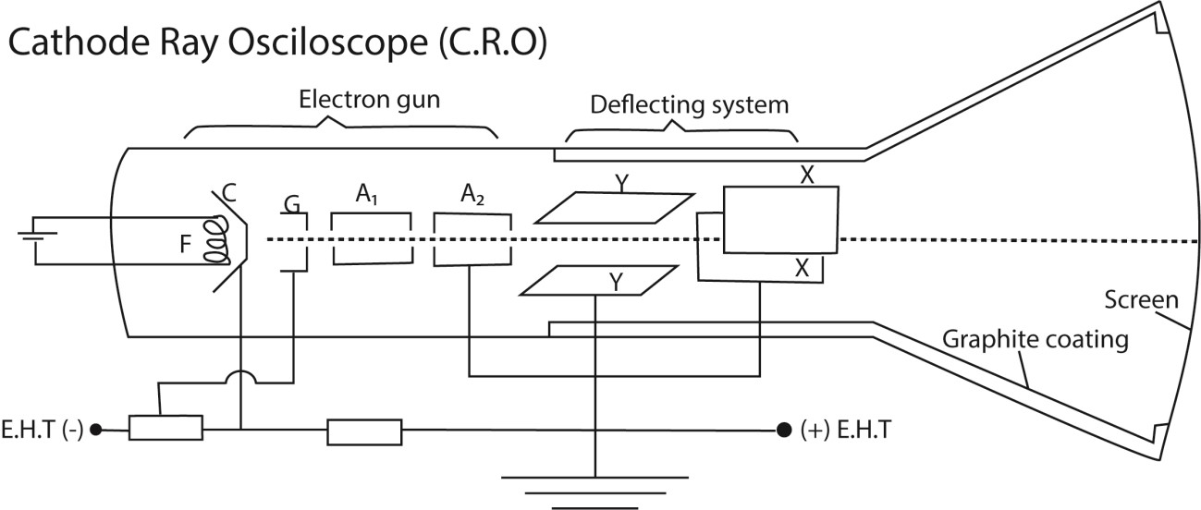
Structure The C.R.O consists of three principal components or features, namely
- The electron gun made of the following;
  - The Filament F: When a current flows through the filament, it glows and heat from the filament heats the cathode.
  - The Cathode C: Emits electrons when heated by the filament.
  - The Grid G: the grid is made at a negative potential with respect to the cathode. It controls the number of electrons entering the Anode, thus the Grid controls the brightness on the screen.
  - Accelerating and focusing Anode A1 and A2: the anode is at a positive potential. It accelerates the electron beam to a high speed along the tube.

- The deflecting system consists of the X -Plates and Y – plates;
  - X – Plates are placed vertically and form a horizontal electric field. Therefore it deflects the electron beam horizontally.
  - Y – Plates are placed horizontally and form a vertical electric field. Therefore it deflects the electron beam vertically.

- The fluorescent screen coated with a fluorescent material such as Zinc sulphide or Phosphor. The fluorescent screen emits light (glows) when struck by fast moving electrons.
Graphite coating:
This is used:
(i) to prevent the electron beam from the influence of electric field (ii) It collects secondary electrons emitted by the screen to the earth.

Mode of action of a C.R.O
- The cathode is heated using a low voltage supply and produces electrons by the process of thermionic emission.
- The electrons are accelerated and focused into a fine beam by the anode to fall on the screen producing a bright spot.
- The brightness of the spot on the screen is controlled by the control grid

How the grid controls the brightness of the spot of a C.R.O
- The grid is connected to a negative potential.
- If the potential of the grid is more negative, only few electrons with high K.E (or speed) will pass through it. Thus the screen will be less bright.
- If the potential of the grid is less negative, many electrons will pass through it. Thus the screen will be brighter.

Deflection; Time-base
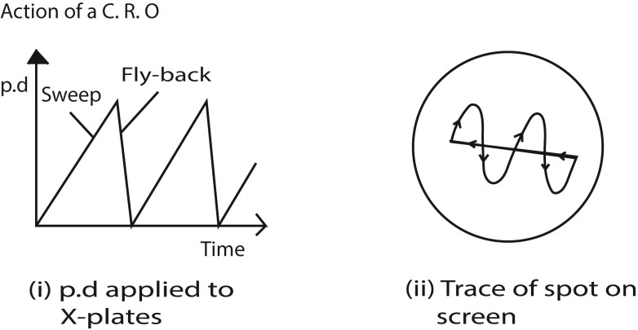
If a battery were connected between the Y-plates, so as to make the upper one positive, the electrons in the beam would be attracted towards that plate, and the beam would be deflected upwards. In the same way, the beam can be deflected horizontally by a potential difference applied between the Xplates.
When the oscillograph is in use, the alternating potential difference to be examined is applied between the Y-plates. If that were all, then the spot would be simply drawn out into a vertical line.
To trace the wave-form of the alternating potential difference, the X-plates are used to provide a timeaxis.
A special valve circuit generates a potential difference which rises steadily to a certain value, as shown in (i), and then falls rapidly to zero; it can be made to go through these changes tens, hundreds, or thousands of times per second.
This potential difference is applied between the ·x-plates, so that the spot is swept steadily to the right, and then flies swiftly back and starts out again.
This horizontal motion provides what is called the time-base of the oscillograph.
On it is superimposed the vertical motion produced by the Y-plates; thus, as shown in Fig. ii) above, the wave-form of the potential difference to be examined is displayed on the screen.
Uses of a C.R.O
- Measures both a.c and d.c voltages
- Measures frequencies or compare frequencies
- Measures phase difference
- Measure small time intervals (used as a clock)
- Displays wave forms
- diagnosis heartbeat and brain in hospitals.

Comparison of CRO with a moving coil Voltmeter
- The C.R.O has very high impedance. It gives accurate voltages than a moving coil voltmeter.
- A CRO can measure both d.c and a.c voltage. A moving coil voltmeter measures only D.C voltages unless a rectifier is used.
- A CRO has negligible inertia as compared to a moving coil voltmeter. The C.R.O respond almost instantaneously.
- CRO doesn’t give direct voltage readings.

Uses of Oscillograph
In addition to displaying waveforms, the oscillograph can be used for measurement of voltage, frequency and phase.
- A.C. voltage
An unknown a.c. voltage, whose peak value is required, is connected to the Y-plates. With the timebase switched off, the vertical line on the screen is centered and its length then measured as shown in figure (i) below. This is proportional to twice the amplitude or peak voltage, V₀. By measuring the length corresponding to a known a.c. voltage V, then V₀ can be found by proportion.

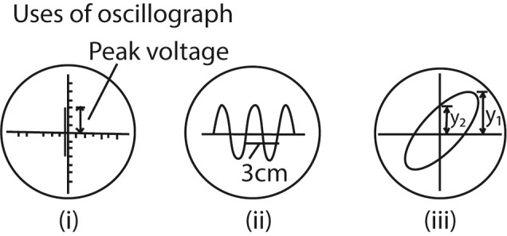
Alternatively, using the same gain, the waveforms of the unknown and known voltages, V and V₀, can be displayed on the screen. The ratio V/V₀ is then obtained from measurement of the respective peak-to-peak heights.

- Comparison of frequency

If a calibrated time-base is available, frequency measurements can be made. In Fig. (ii) above, for example, the trace shown is that of an alternating waveform with the time-base switched to the '5 millisec/cm' scale. This means that the time taken for the spot to move 1 cm horizontally across the screen is 5 milliseconds. The horizontal distance on the screen for one cycle is 3 cm. This corresponds to a time of 5 x 3 ms or 15·0 ms = 15 x 10⁻³ seconds, which is the period T.
If a comparison of frequencies, f₁, f₂ is required, then the corresponding horizontal distances on the screen are measured. Suppose these are d₁, d₂ respectively.

Since f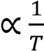, then 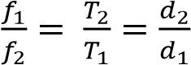

- Measurement of phase

Positive rays
- Positive rays are streams of positively charged particles.

Production of positive rays in a discharge tube
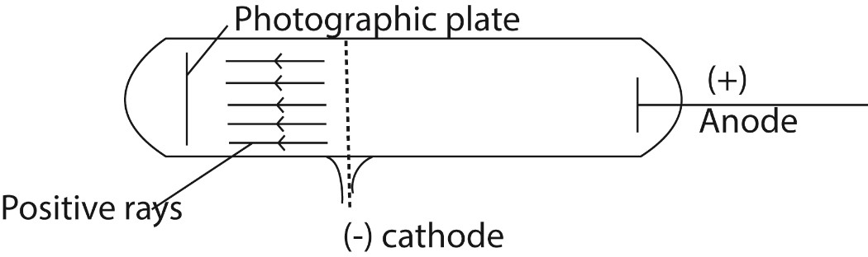
- Positive rays are produced when a stream of electrons is passed through a vapor (gas) in discharge tube.
- The electrons dislodge electrons from the atoms producing positively charged ions.
- The positive ions are accelerated towards perforated cathode.
- The ions pass through the slits and are further accelerated. - These ions constitute a stream of positive rays.

Properties of positive rays
- They travel in straight lines
- They are positively charged
- They are more massive compared to cathode rays
- They are reflected by strong magnetic fields
- They have smaller specific charge (q/m) compared to the cathode rays (this is because they are more massive than the cathode rays)
- They are deflected by strong electric fields in opposite direction to that of the cathode rays in the same field

Electron dynamics
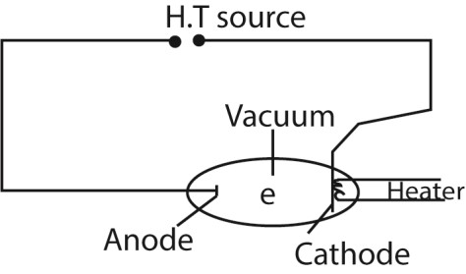
Consider an electron moving from cathode to anode.
- Let the p.d between the cathode and anode be V. The electron will be accelerated by the electric field and hence it gains K.E.
- If the electron starts from the cathode with zero velocity and reaches the anode with velocity ums^{-I}, then the K.E gained by
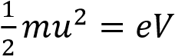, where e = electron charge, 1.6 x 10⁻¹⁹C
Or
u = 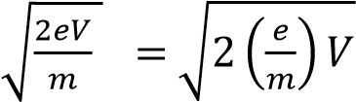

The quantity 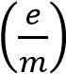 is called the specific charge of the electron

Deflection of an electron in a magnetic field
Consider an electron entering a uniform magnetic field of flux B, at right angles to its direction of motion with velocity u.
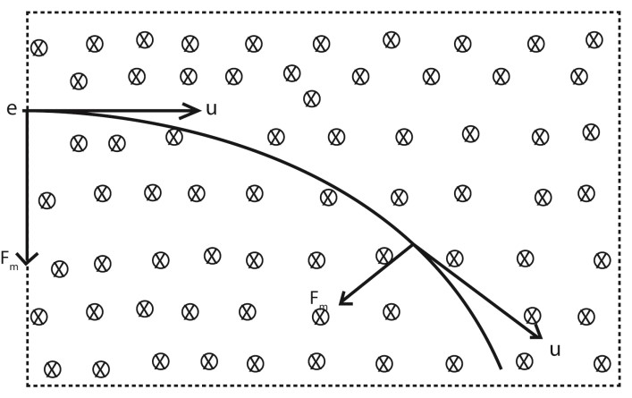
When the electron enters the field, the magnitude of its speed u does not change because the magnetic force is perpendicular to the direction of the electron, But instead its direction changes and the electron moves in a circular arc.
Let r be the radius of the circular arc (path)
The centripetal force on the electron, F = 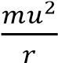 …………………………………. (i)
The force due to the magnetic field, F = Beu ………………………………….. (ii) From (i) and (ii)
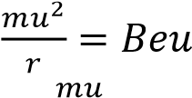
r = 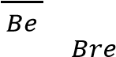 and u =

Since the speed of the electron is constant, its K.E is also constant hence,
Kinetic energy = 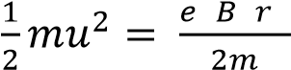

Example 1
An electron moves in a circular path at 3.0 x 10⁶m/s in a uniform magnetic field of flux 2.0 x 10⁻⁴T. Find the radius of the path.
[mass of an electron m_{e} = 9.11 x 10⁻³¹kg, e = 1.6 x 10⁻¹⁹C] r = 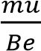
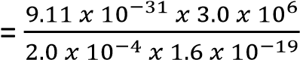
= 8.5cm

Crossed fields
Crossed fields are fields in which a uniform magnetic field and a uniform electric field are perpendicular to each other producing deflections opposite to each other. If the magnetic force and electric force in the crossed fields are of the same magnitude, there is no deflection on charged particles that enter such fields.
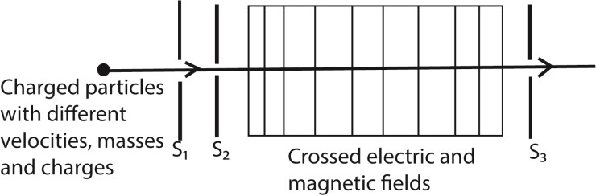
The slits S₁ and S₂ confine the particles into a narrow beam as they enter the crossed fields. The only particles that emerge at slit S₃ are those which are undeflected, and therefore they emerge with the same velocity u.
The electric force F_{E} due to the electric field = eE
The magnetic force F_{m} due to the magnetic field = Beu For crossed fields F_{E} = F_{m}
eE = Beu
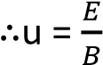 this is the velocity of particles emerging at S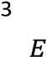
Therefore all particles that emerge at S₃ will have the same velocity u = regardless of their mass and charge.

The crossed fields can be used as a velocity selector of particles of a single velocity from a beam of particles of different velocities.

Example 2
An electron accelerated by a p.d of 1.5KV passes through an electric field crossed with a uniform magnetic field of flux density 0.45T. Calculate the value of the electric field needed for the electron to emerge undeflected.

Solution u =
Also,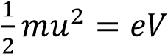
u = 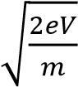
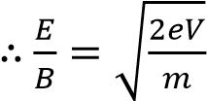
E = 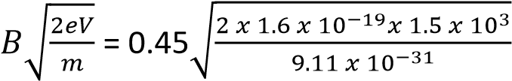 = 1.033 x 10⁷NC⁻¹

Determination of Specific Charge 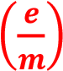of an electron: (J.J Thomson’s Method)
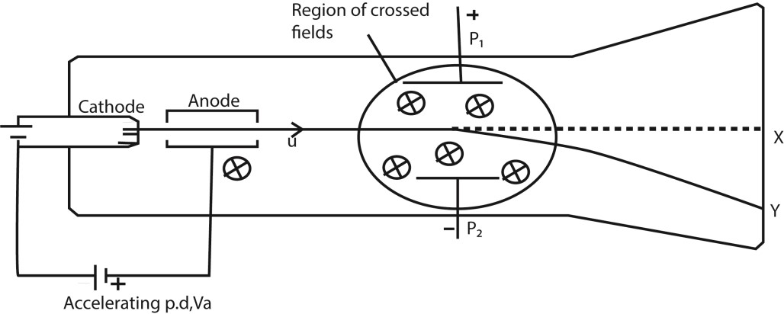

- The electrons are produced thermionically by a hot filament cathode and are accelerated towards a cylindrical anode and pass through it.
- The small hole on the anode confines the electrons to a narrow beam.
- When both the electric field and the magnetic field are off, the electrons reach the screen at X and cause fluorescence.
- If the velocity of the electrons on emerging from the anode is u then eV_{a} 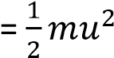
⇨ 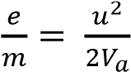 ………………………………………. (i)
Where V_{a} is the accelerating voltage between the cathode and anode.

- The magnetic field is switched on and the beam is deflected to position Y.
- In order to bring the beam back to the original position X, the electric field is switched on and adjusted until the beam is at X again.
- This implies that The magnetic force = the electric force
Beu = eE
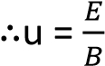 ………………………………. (ii)
Substituting eqn. (ii) in (i)
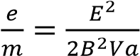 but E = 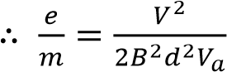 where, V is the p.d between the plates at separation of d apart

Example 3
A beam of electrons is accelerated through a p.d of 500V and enters a uniform electric field of strength 3.0x10³V/m created by two parallel plates of length 2.0cm. Calculate:
(a). the speed of the electrons as they enter the field.
From 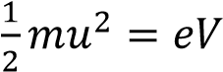
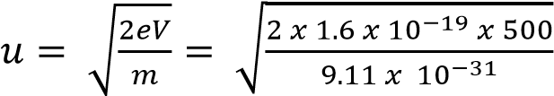 = 1.325 x 10⁷ms⁻¹
(b). the time that each electron spends in the field.
t= 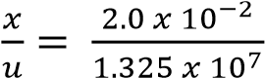 = 1.51 x 10⁻⁹s
(c). the angle from which the electrons have been deflected by the time they emerge from the field.
u_{x} = u = 1.325 x 10⁷ms⁻¹ u_{y} = a_{y}t but a_{y} 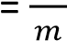
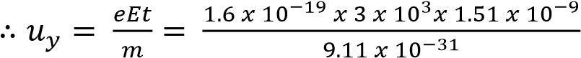 = 7.956 x 10⁵ms⁻¹
Let the angle be θ
tan θ = 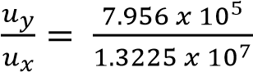 θ = 3.8⁰

Motion of an electron in an electric field
Consider two parallel plates AB and PQ such that AB is vertically above PQ and at a distance d apart. Let x be the length of the plates and V the p.d between the plates.
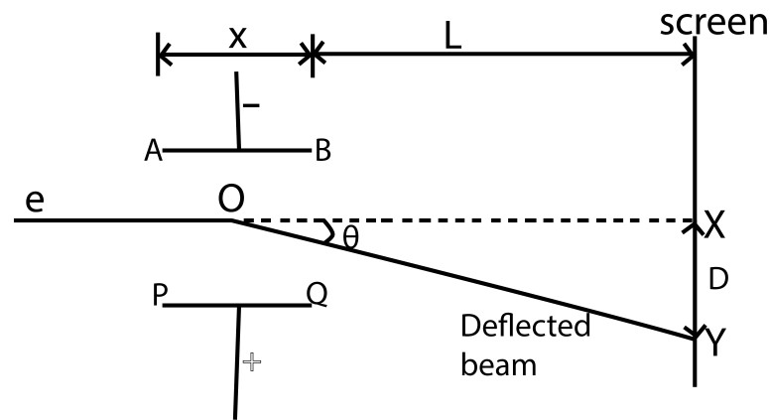
This electric force is directed towards the positive plate causing the deflection of the beam as shown above.
But for parallel plates E =
Thus F_{E} 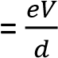
Since the electric field intensity is vertical, there is no horizontal force acting on the electron. Hence the horizontal component of the velocity of the electron does not change.
Let u be the horizontal component of the velocity of the electron entering the electric field. Motion in the X-direction s = ut + ½ at², but s = x and a =0
⇨ t = ……………………………….. (i)
Motion in y-direction s = ut + ½ at², but u_{y} = 0, s = y and a = 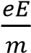 from ma = eE
y = 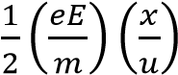
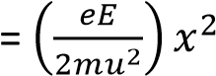
⇨ y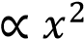 or y = kx² which is an equation for parabola
Thus the motion of an electron in electric field is parabolic
Note
- The time, t, taken for the electron to pass through the electric field (leave the plates) t =
- The velocity, V₀ with which electrons leave the plates
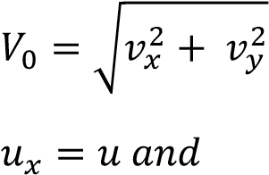
also t = where x is the length of the plates
Thus 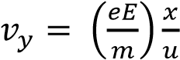 where E =
- Direction (angle) the electron emerges from thee region between the plates at angle θ given by
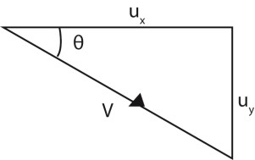
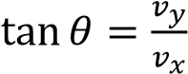
- The deflection D of the electron on the screen placed at a distance L from the edge of the plates is obtained from
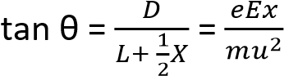
hence D = 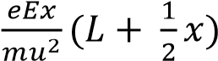 where E =

Example 4
A beam of electrons is accelerated through a p.cd of 2000V and is directed mid-way between two horizontal parallel plates of length 5.0cm and separation of 2.0cm. The p.d across the plates is 80V.
- Calculate the speed of the electrons as they enter the region of between the plates
From 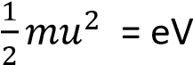
u_{x} 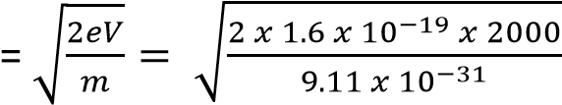 = 2.65 x 10⁷ms⁻¹
- Find the speed of the electrons as they emerge from the region between the plates.
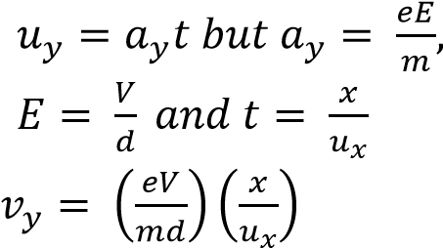
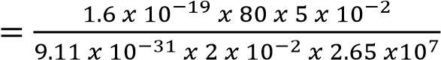

= 1.325 x 10⁶ms⁻¹

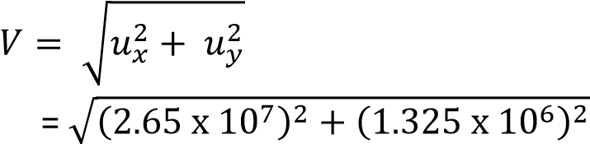
= 2.653 x 10⁷ms⁻¹
- Explain the motion of the electrons between the plates.
It is parabolic

Example 5
An electron gun operated at 3x10³V is used to project electrons into the space between two oppositely charged parallel plates of length 10cm and separation 5cm. Calculate the deflection of the electrons as they emerge from the region between the charged plates when the p.d is 1.0x10³V.

From ½ mu² = eV u = 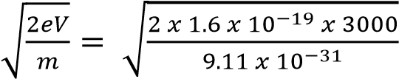 = 3.246 x 10⁷ms⁻¹
Also y =
- y = 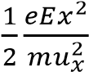 and E =
- y = 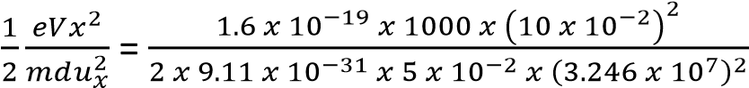 = 1.667 x 10⁻²m

Therefore, the deflection= 1.667 x 10⁻²m

Millikan’s Oil drop experiment
This is used to determine electronic charge e
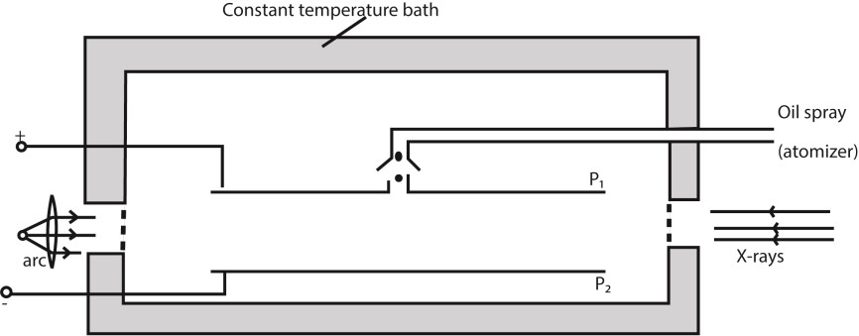

Procedure
- Set up of the apparatus is as shown above
- Oil drops are introduced between the plates P₁ and P₂ by spraying using the atomizer.
- These oil drops are charged in the process of spraying by friction but the charge may be increased by ionization using X-rays.
- The oil drops are strongly illuminated by an intense light from the arc lamp so that they appear as bright spots when observed through a low power microscope.
- With no electric field between the plates, record the time t₁ taken for drop to fall from P₁ to P₂.
- The electric field between the plates is turned on and adjusted so that the drop becomes stationary.

Case 1
With no electric field, the oil drop falls with a uniform velocity v₁ called terminal velocity

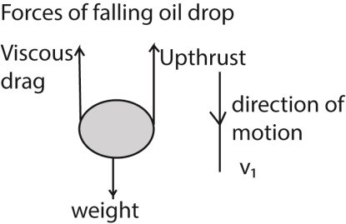
Weight = Upthrust + viscous drag ……………………………… (i)
= volume of the oil drop x density x gravity
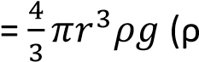= density of oil, r = radius of oil drop)
Upthrust = weight of air displaced by oil drop
= volume of the air displaced by oil drop x density x gravity
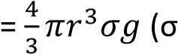= density of air)
Viscous drag = 6πrηv₁ (From strokes’ law)
From 1
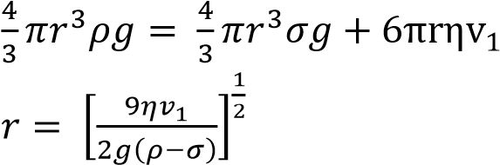 …………………… (ii)

Case 2
When the electric field is applied so that the drop is stationary, the drop has no velocity and no acceleration.
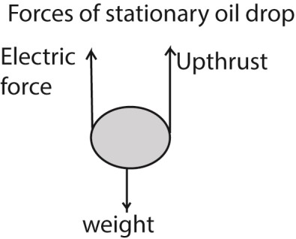
Weight = Upthrust + electric force
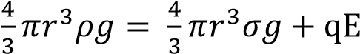 …………………… (iii)
From (ii) and (iii)
q = 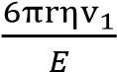 but E =
Substituting for r
q = 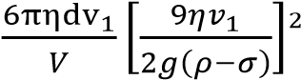
Note: the density of air at room temperature is very small compared to that of oil and thus may be assumed negligible (when it’s not given) in calculations. This implies that the up thrust due to the displaced air is Zero.
q = 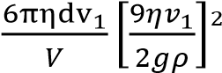

Precautions
To improve on the accuracy of the experiment, the following precautions need to be taken into account
- A non-volatile oil or low vapor pressure oil should be used to reduce evaporation since evaporation would alter the mass of the drop
- The experiment is enclosed in a constant temperature enclosure. This is to eliminate convection currents and changes in the viscosity of air as a result of temperature changes.
- An X-ray tube is used to increase the charge of the oil drop.

Example 6
Oil droplets are introduced into the space between two flat horizontal plates, set 5.0mm apart. The plate voltage is then adjusted to exactly 780V so that one of the droplets is held stationary. Then the plate voltage is switched off and the selected droplet is observed to fall a measured distance of 1.5mm in 11.2s. Given that the density of the oil used is 900kgm⁻³ and the viscosity of air is 1.8 X 10⁻⁵Nsm⁻², find; i) The radius of the oil drop
Weight = Upthrust + viscous drag
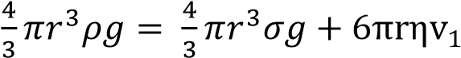

Density of air is negligible, ς = 0
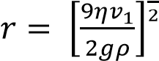
Velocity, v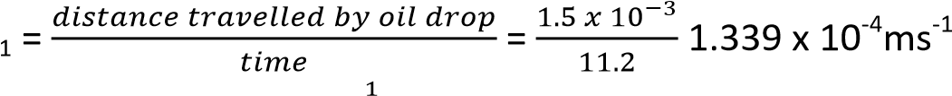
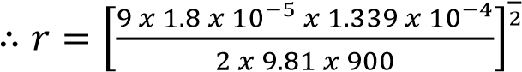= 1.1 x 10⁻⁶m

- The charge of the droplets
Weight = Upthrust + electric force
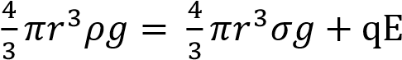
But ς = 0 (can be neglected, E =
q = 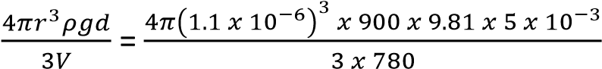 = 3.2 x 10⁻¹⁹C

- The number of electrons on the drop
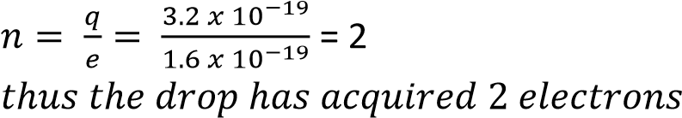

Example 7
- Calculate the radius of a drop of oil of density 900kgm⁻³ which falls with a terminal velocity of
2.9 x 10⁻⁴m/s through air of viscosity 1.8 X 10⁻⁵Nsm⁻².
Weight = Upthrust + viscous drag
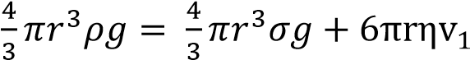

Density of air is negligible, ς = 0
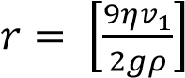
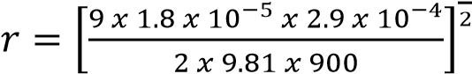 = 1.63 x 10⁻⁶m
- If the charge on the drop is -3e, what p.d must be applied between the plates 5.0mm apart in order to keep the drop stationary?
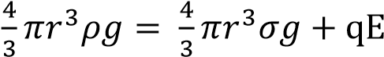
But ς = 0 (can be neglected, E =
V = 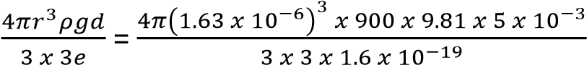 = 1,668V

The Bainbridge Mass Spectrometer
Consists of three main parts, namely
- Accelerating electric field
- Velocity selector
- Deflecting chamber

Uses of a Bainbridge mass spectrometer
- To measure the specific charge of positive rays or ions
- To separate isotopes of an element
- To determine the atomic masses of the positive rays or ions

Determination of specific charge of positive ions using a Bainbridge spectrograph
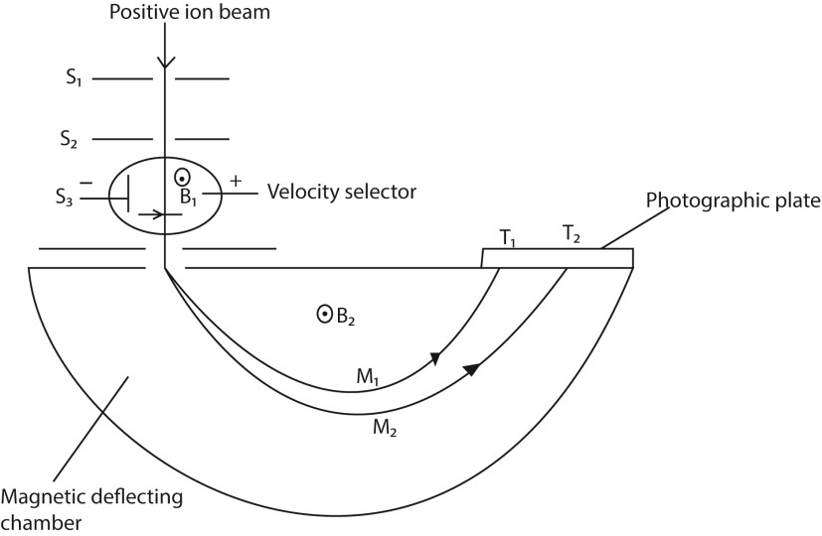
T₁ and T₂ are tracers on photographic plate, S₁, S₂ and S₃ are slits

Mode of Action
- Positive ions are produced in a discharge tube and admitted as a beam through slits S₁ and S₂.
- The beam then passes between insulated plates P, Q, connected to a battery, which create an electric field of intensity E.
- A uniform magnetic field B₁, perpendicular to E is applied over the region of the plates and all ions, charge e with the same velocity, v given by B₁ev =Ee will then pass undeflected through the plates and through a slit S₃.
- The selected ions are deflected in a circular path of radius r by a uniform perpendicular magnetic field B₂ and an image is produced on a photographic plate as shown. In this case
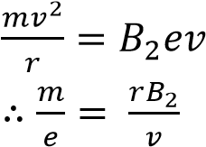

But for the ions selected v = 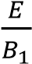 from above
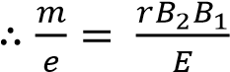

Or specific mass-charge ratio or specific charge,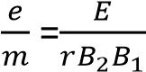, 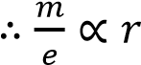, for given magnetic and electric fields.
Since the ions strike the photographic plate at a distance 2r from the middle of the slit S₃, it follows that the separation of ions carrying the same charge is directly proportional to their mass. Thus a 'linear' mass scale is achieved.
Ionic separation is obtained by
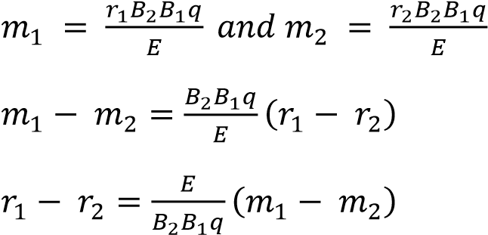
Where 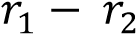= ionic separation

Example 8
The magnetic flux density in both fields is 0.4T and the electric field in the velocity selector is 2x10⁴Vm.
- What is the velocity of an ion which goes un deviated through the slit system
B₁ = B₂ = B = 0.4T and E = 2 x 10⁴Vm
For crossed fields in the velocity selector
B₁qu = Eq
u = 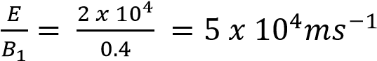
- The source is set to produce singly charged ions of magnesium isotopes as Mg – 24 and Mg – 26. Find the distance between the images formed by the isotopes on the photographic plate, assuming the atomic masses of the isotopes are equal to their mass numbers numerically. In the deflection chamber, F_{m} = F_{e}
B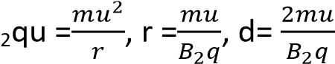 since r =
Also m₁ = 24U and m₂ = 26U
d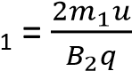 and d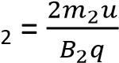
dm
- Calculate the ratio of the times the two isotopes take to complete a semi-circle. {Assume 1U =
1.67x10⁻²⁷kg and e = 1.60x10⁻¹⁹C}
Radius, r = and circumfrence of semicircle = 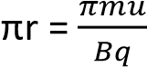
Time taken to complete semi-circle = 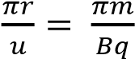
Ration of time form Mg-24 and Mg-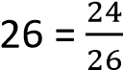

TOPIC 2/3: QUANTUM THEORY
Competency: The learner examines how electromagnetic waves carry energy in packets and that this behaviour can be harnessed in a variety of fields.

Photoelectric effect
Photoelectric effect is the emission of electrons from a material caused by light or electromagnetic radiations.
In metals, atoms exist as positive ions in a sea of electrons. An electron near the surface of the metal, say A, experiences an attractive inward force from the positive charges below it.
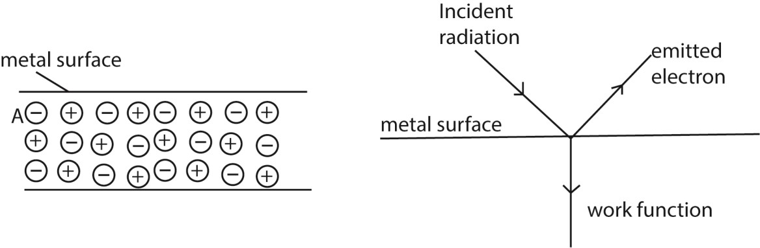
For such an electron to escape from the metal surface, a specific amount of work has to be done to overcome these inward forces.

Terminologies
Photoelectric emission is the liberation of electrons from a metal surface by use of light of a suitable frequency. That is, the light (radiation) supplies the electrons with an amount of energy equal or exceeding the energy that binds them to the surface.
Thermionic emission is the liberation of electrons from a metal surface by application of heat.
Photoelectrons are electrons liberated by light striking a metal surface.
Photo emissive surfaces are metal surfaces that emit electrons when struck by light.
Generally K, Na, Ca and other elements with low ionization energy or work functions have surfaces that are photo emissive.
Work function is the minimum energy required to liberate an electron from a metal surface. Each element is characterized by a specific value of work function.

Laws of photoelectric emission
The laws, characteristics or features of photoelectric emission are a summary of experimental results on photoelectric effect.
- The time lag between irradiation of the metal surface and emission of the electrons by the metal surface is negligible.
- For a given metal surface, there is a minimum value of frequency of radiation called threshold frequency (f₀) below which no photo electrons are emitted from the metal however intense the incident radiation may be.
- The number of photoelectrons emitted from the surface per second is directly proportional to the intensity of incident radiation for a particular incident frequency
- The K.E of the photoelectrons emitted is independent of the intensity of the incident radiation but depends only on its frequency

A simple experiment to demonstrate Photo electric effect
- A freshly cleaned Zinc plate is connected to the cap of a negatively charged gold leaf electroscope.
- Ultra violet radiations are allowed to fall on the zinc plate
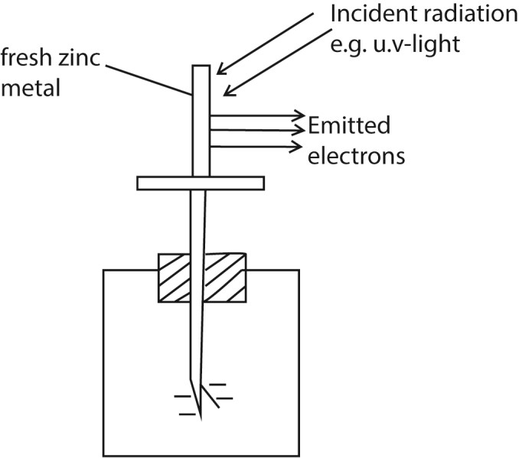

Observations
- The leaf of the electroscope gradually falls
- This shows that both the zinc plate and the electroscope have lost charges.
- The lost charges are found to be electrons, hence photoelectric effect has occurred.

Note: If a positively charged electroscope is used instead, there is no observable change in the divergence of the leaf because the emitted electrons are immediately attracted back by the positive charges on the cap of the electroscope hence restoring the charges.

Planks Quantum theory
States that the energy /radiation emitted or absorbed by an electron is discrete or in packets called quanta.
That’s, we can have integral values such as 1, 2, 3 … n, but not fractional amount of energy
The energy E, contained in a quantum of radiation is proportional to the frequency f, of the radiation i.e. E  f or E =hf where h = Planks constant (6.626 x 10⁻ ³⁴Js)

Dimensions of h
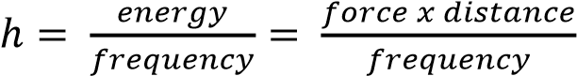

For an electromagnetic radiation of wavelength, λ; we have c= λf
⇨ E =
Thus E f and E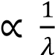

When the photon (of energy hf) collides with an electron, it is either
- Reflected with no change in its energy or
- Absorbed by the electron and the photon gives up all its energy to that single electron without sharing with other electrons
If the energy E, (hf) is greater than the work function (w_{o}) of the metal, the excess energy (hf - w_{o}) is absorbed as the K.E of the emitted electron or photoelectron
i.e. hf –w₀ = ½ mv² where v is the velocity of emitted electron or hf= w₀ + ½ mv² ; also called Einstein photo electric equation

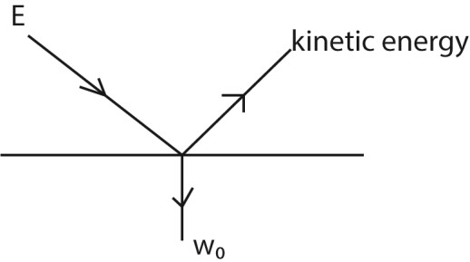

Since the work function w₀ is constant for a particular metal, there exists a minimum frequency
(threshold frequency, f₀) given by w₀ = hf₀ From, hf –w₀ = ½ mv² then h(f-f₀) = ½ mv²
Also, w₀ = hf₀ and f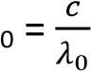
- w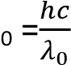
- If an electron of charge e is accelerated by a voltage V volts, it gains K.E given by K.E = eV. Hence from above h(f – f₀) = eV
- An electron volt (eV) is the K.E gained by an electron which has been accelerated through a p.d of one volt
- 1eV = 1.6 x 10⁻¹⁹J
- The values of the constants are h = 6.64 x 10⁻³⁴Js, c = 3.0 x 10⁸ms⁻¹, e = 1.6 x 10 ⁻¹⁹C

Definitions
Threshold wavelength is the maximum wavelength that is required to emit the electrons from a metal in the photo electric effect
Threshold frequency is the minimum frequency of incident radiation below which photoelectric emission cannot occur.

Example 1
Monochromatic radiation of frequency 1.0 x 10¹⁵ Hz is incident on a clean magnesium surface for which the work function is 0.59 x 10⁻¹⁸J. Calculate
- the maximum kinetic energy of the emitted electrons kinetic energy = hf – w₀
= 1 x10¹⁵ x 6.64 x 10⁻³⁴ – 0.59 x 10⁻¹⁸J
= 7.4 x 10⁻²⁰J
- the potential to which the magnesium surface must be raised to prevent the escape of electrons potential energy = kinetic energy eV = 1.04 x 10⁻¹⁹J
V = 7.4 x 10⁻²⁰J/1.6 x 10⁻¹⁹
= 0.46V (iii) The cut-off wavelength.
From w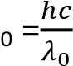
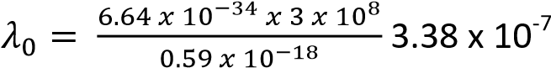m

Example 2
Calcium has a work function of 2.7eV.
- What is the work function of calcium in Joules?

1eV = 1.6 x 10⁻¹⁹J
2.7eV = 2.7 x 1.6 x 10⁻¹⁹ = 4.3 x 10⁻¹⁹J
- What is the threshold frequency of calcium?
hf₀ = 4.3 x 10⁻¹⁹
6.64 x 10⁻³⁴ x f₀ = 4.3 x 10⁻¹⁹
f₀ = 6.5 x 10¹⁴Hz

- What is the maximum wavelength that will cause emission from calcium metal? 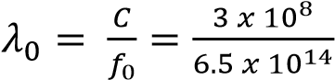= 4.6 x 10⁻⁷m

Example 3
Light of frequency 6 x 10¹⁴Hz is incident on a metal surface and the emitted electrons have kinetic energy of 2 x 10⁻²⁹J. Calculate:
- Work function
From hf = w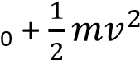
6 .63 x 10⁻³⁴ x 6 x 10¹⁴ = w₀ + 2 x 10⁻²⁹ w₀ = 3.978 x 10⁻¹⁹J
- Threshold frequency of the metal. From w₀ = hf₀
3.978 x 10⁻¹⁹ = 6 .63 x 10⁻³⁴ x f₀
f₀ = 6 x 10¹⁴Hz

Example 4
Calculate the maximum speed of photoelectrons emitted by a cesium surface when irradiated with light of wavelength 484mm if the work function of cesium is 3 x 10⁻¹⁹J.
(c = 3 x 10⁸ms⁻¹, h= 6.63 x 10⁻³⁴Js, Me = 9.1 x 10⁻³¹kg)
From hf = w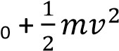
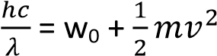
v = 4.938 x 10⁵ms⁻¹

Example 5
A photo emissive metal has a threshold wavelength of 0.45μm. Calculate the kinetic energy of emitted electrons when light of wavelength 0.35μm falls on this metal
(c = 3 x 10⁸ms⁻¹, h= 6.63 x 10⁻³⁴Js)
From 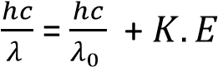
K.E = 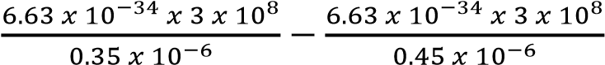 = 1.263 x 10⁻¹⁹J

The Photocell
A photocell is a unit that changes radiation/light energy into electric current. The structure of a photocell is illustrated below
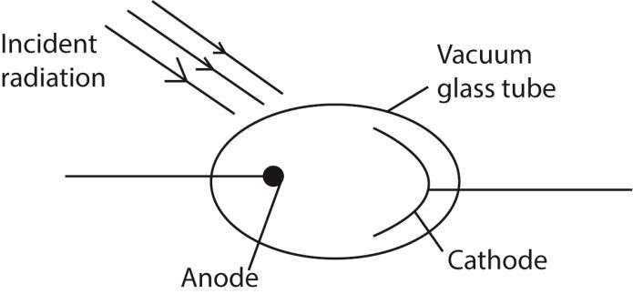
• It consists of an anode made of a thin wire so that it does not obstruct the incident radiation and a photo-emissive cathode of a large surface area to collect large amount of light radiations placed in a vacuum because the metals are reactive.

Applications of Photocells
- It used to demonstrate photoelectric emission.
- It used to determine the stopping voltage of a particular in order to derive the planks constant, h, the work function, threshold frequency and threshold wavelength of a particular metal.
- A photocell can make doors open automatically in buildings when a light beam is interrupted by somebody/obstacle.
- Intruder alarm systems. The intruder intercepts the infrared beam falling on a photocell, hence cutting off of current. This interruption therefore sets the alarm on.
- Photovoltaic cells are used in solar panels, calculators and for powering electronic watches.
- Used as automatic devices for switching on light at night when it tries to darken or when the frequency of the light reduces.
- Automatic counting machines in industries.
- Production of sound from a film

Stopping potential
Stopping potential is the minimum potential between the cathode and the anode that prevents the most energetic electrons from reaching the anode.

Experiment to measure the stopping potentials in order to verify Einstein’s photoelectric equation and to determine Plank’s constant h

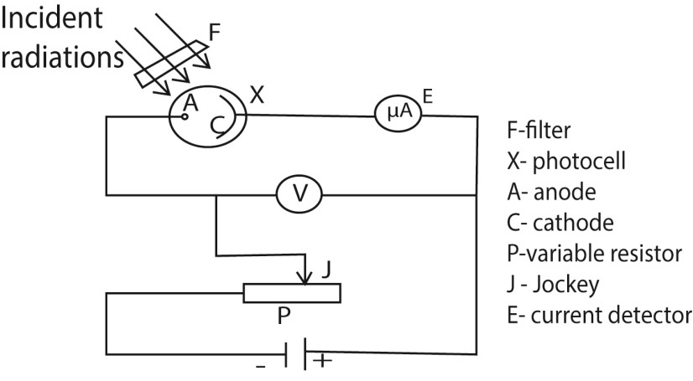
- A radiation of known frequency, f, is made incident on the photocathode
- Emitted electrons travel to the anode and cause a current to flow that is detected at E.
- The p.d V is adjusted until the reading of E is zero or when there is no current flow.
- The minimum value of p.d that prevents the most energetic electron from reaching the anode called the stopping potential (Vs) is recorded from the voltmeter V. - The procedure is repeated with light of different frequencies, f.
- A graph of stopping potential (Vs) against frequency (f) is plotted

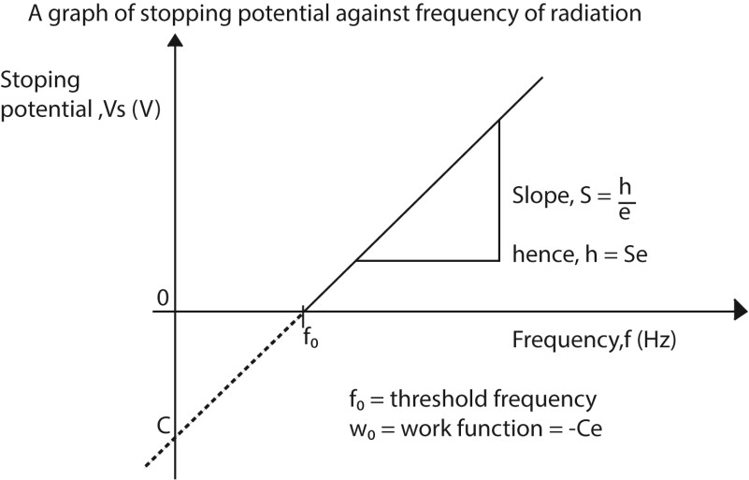
From the graph
- Threshold frequency, f₀ is intercept on the frequency (horizontal) axis.
- Slope of the graph, S = where e is the electron volt; hence, Plank’s constant , h = Se
- The nature of the curve verifies the equation i.e. 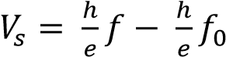
- The work function, w₀ = -Ce, where C is the intercept on the vertical axis
Also threshold wavelength, 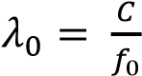
- When the experiment is carried out on different metals of different work functions, parallel graphs are obtained with constant slope, S = as illustrated below
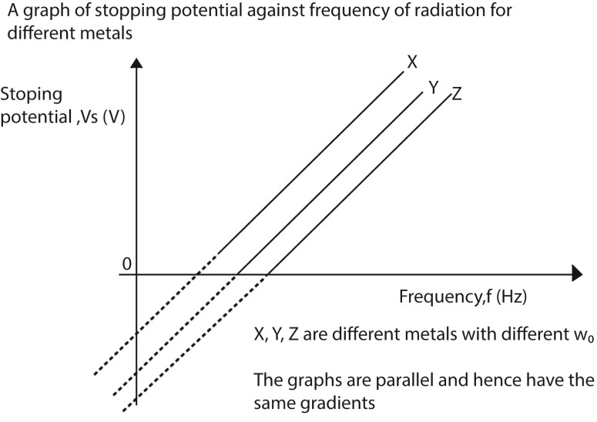
Note that;
- The elements X, Y and Z have different work functions
- The graphs are parallel because they have the same gradient, S =

Example 6
Sodium has a work function of 2.3eV. Calculate the
- Threshold frequency From w₀ = hf₀
2.3 x 1.6 x 10⁻¹⁹ = 6.63 x 10⁻³⁴f₀ f₀ = 5.55 x 10¹⁴Hz
- Stopping potential when it is illuminated by light of wavelength 5 x 10⁻⁷m (1eV = 1.6 x 10⁻¹⁹J)

From hf = hf₀ + eV
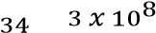
V = 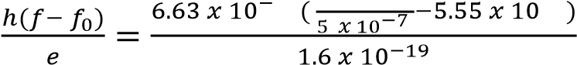 = 0.186V

Explanation of the laws of photoelectric emission using quantum theory
The quantum theory states that “light is emitted and absorbed in discrete packets of energy called photons”
When light is incident on a metal surface, each photon interacts with a single electrons giving it all its energy. The photon is absorbed if its energy is greater than the work function and if it is less, the photon is rejected.
Increasing the intensity of light increases the number of photons striking the metal surface per second. Therefore more electrons are emitted per second and the photocurrent increases with intensity.

Increasing the frequency of incident radiation increases the energy of each photon and therefore the maximum kinetic energy of the liberated electrons increases with the frequency of radiation.

Increasing the intensity of light only increases the number of photons but not the energy in each photon. Hence kinetic energy of the emitted electrons is independent of the intensity of the incident radiation
i.e K.E = hf + w₀ where K.E = kinetic energy of emitted electron, h = Plank’s constant, f = frequency of the radiation, w₀ = work function (minimum energy required to dislodge an electron from a material)

Failures of the wave theory (classical theory) to account for the photoelectric emission

(i) Existence of threshold frequency
According to the classical theory, the energy of the incident radiation depends on its intensity; the greater the intensity of illumination, the greater the supply of energy. This would imply that radiations of high enough intensity should cause emission even when the frequency is below the minimum value. However as long as the incident radiation is below the threshold frequency, no photoelectrons are emitted however intense the incident radiation is

(ii) Instantaneous emission of photoelectrons
Classical theory suggests that the energy of the incident radiation would be continuously absorbed by the electron. Implying that the electron would take some time to accumulate sufficient energy that would enable them escape from the metal surface. By this theory, emission of photoelectrons would not be instant

(iii) Variation of K.E of the emitted photoelectrons
According to the classical theory, increasing the intensity of the incident radiation would mean more incident energy and a greater maximum K.E of the emitted photoelectrons. But instead the maximum K.E of the photoelectrons emitted depend on the frequency of the incident radiation.

(iv) Variation of photoelectric current with intensity
When the intensity of illumination is increased, the number of photons incident on the metal surface also increases. Hence more free electrons in the metal receive sufficient energy to escape. The rate of emission increases and therefore a large current flows. Thus the size of the photocurrent depends on the intensity of the incident radiation. However, According to classical theory, increase in the intensity would increase the K.E of the emitted electron and they would escape with greater speed instead, which is false

Experiment to show the variation of current (I) with p.d (V) of a photocell
The setup is shown below
- A monochromatic light i.e. constant frequency is used.
- The photocurrent (I) is measured for increasing values of V at constant light intensity.
- For negative values of V, the polarity of the battery is reversed.
- The experiment is repeated by increasing the intensity of the radiations; by moving the light source closer to the photocell.
- A plot of graphs of photocurrent (I) against the p.d V is shown below.

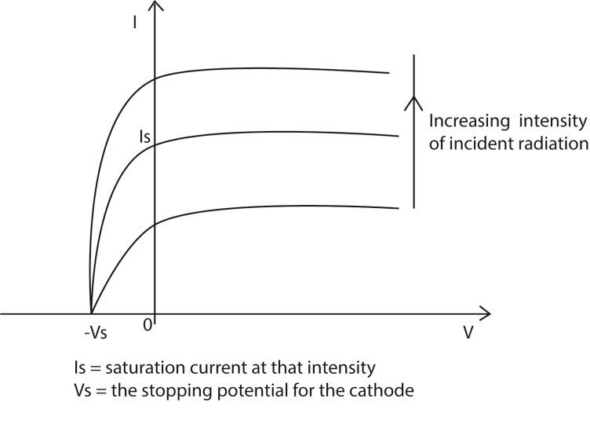
Note that
- Current increases with intensity due to increase in the number of photons striking the cathode/metal surface.
- For each light intensity value, there a maximum current that can be obtained called saturation current. It occurs when the anode collects all the photons emitted by the cathode.
- The photocurrent is not zero even when the p.d is zero because electrons are emitted with varying velocities (K.E). Hence, some of the electrons have sufficient energy to overcome the repulsive electric field and reach the anode.

Example 7
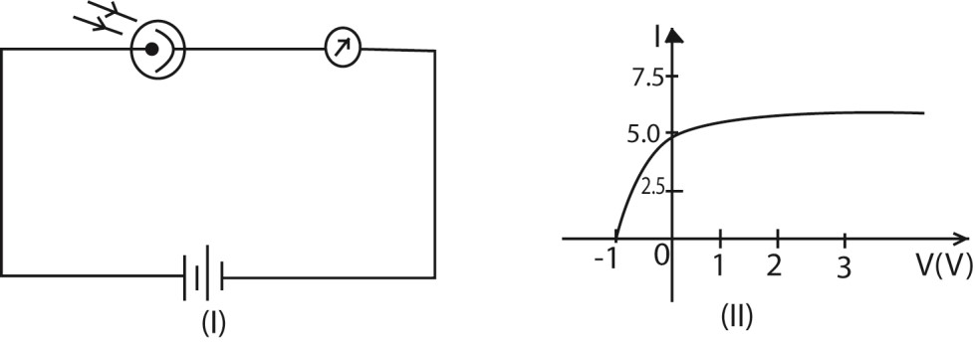

A photocell is connected in the circuit as shown in figure (I) above. The cathode is illuminated with monochromatic light of wavelength 390nm and the current I in the circuit recorded for different p.d V applied between the anode and the cathode. The graph fig (II) shows the results obtained.
(a) Find the maximum K.E of the photoelectrons
From the graph Vs = -1V
K.E_{max} = eV = 1.0 x 1.6 x 10⁻¹⁹ = 1.6 x 10⁻¹⁹J (b) What is the work function of the cathode in eV?
K.E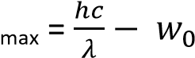
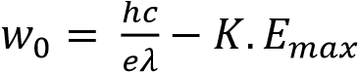
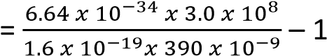
= 2.19eV
(c) If the experiment is repeated using monochromatic light of wavelength 310nm, where would the new graph cut the V-axis?
K.E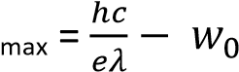
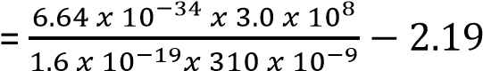
= 1.83eV
Hence the graph would cut the v-axis at – 1.83V

Example 8
A 100mW beam of light of wave length 4.0 x 10⁻⁷m falls on a caesium surface of a photocell. (i) How many photons strike the caesium surface per second?
E= 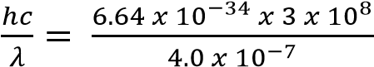 = 4.98 x 10⁻¹⁹J
Number of photons per second, n 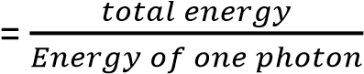
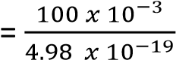
= 2 x 10¹⁷s⁻¹
- If 80% of the photons emit photoelectrons. Find the resulting photocurrent.
Number of electrons emitted = 2 x 10¹⁷s⁻¹ x 80%
= 1.61 x 10¹⁷
Current = ne
= 1.61 x 10¹⁷ x 1.6 x 10⁻¹⁹ = 2.57 x 10⁻²A
- Calculate the kinetic energy of each photoelectron if the work function of caesium is 2.15eV.

K.E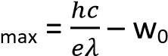 where 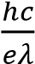 is energy in eV
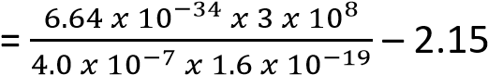
= 0.96eV
=1.54 x10⁻¹⁹J
Or K.E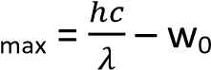
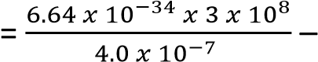2.15 x 1.6 x 10⁻¹⁹
= 1.54 x10⁻¹⁹J

Differences between x-ray production and photoelectric effect

Photoelectric effect | X-rays
Electromagnetic radiation falls on metal surface and electrons are emitted | Fast moving electrons hit the metal target and x-rays (electromagnetic radiation) is produced
Little heat is generated | A lot of heat is generated

Experimental evidence for quantum theory
- Photoelectric effect:
To liberate an electron from a metal surface, a quantum or packet of energy called the work function which is characteristic of the metal surface has to be supplied
i.e. 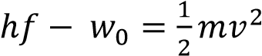 where w₀ is the work function.
- Optical spectra:
A line in the optical emission spectrum indicates the presence of a particular frequency f of light and is considered to arise from loss of energy which occurs in an excited atom when an electron jumps directly or in steps from a higher energy level E₂ to lower energy level E₁. The frequency of the packet of energy emitted is given by hf  E₂  E₁.
- X-ray line spectra:
Electron transition from one shell to another leads to liberation of energy in packets characteristic of the target atom.

Differences between classical theory and quantum theory
Classical(wave) theory | Quantum theory
It allows continuous absorption and accumulation of energy. | No continuous absorption is allowed. The energy is either absorbed or rejected.
Energy of radiation is evenly distributed over the wave front. | Energy is radiated, propagated and absorbed in packets (quanta or photons).
What matters is total energy of the incident radiation (beam). | What matters is the energy of individual photon.

Bohr’s model of the atom and how it can be used to explain
i) origin of absorption and emission spectra; ii) presence of energy levels in atoms; and iii) ionisation in atoms and calculate ionisation energy.
Bohr's model explains atomic phenomena by postulating that electrons orbit the nucleus in specific, discrete energy levels and can transition between them by absorbing or emitting fixed amounts of energy (photons)
.

(i) Origin of Absorption and Emission Spectra
- Quantization Postulate: Bohr proposed that electrons can only exist in specific, stable, circular orbits, each associated with a definite, discrete amount of energy. These are the "energy levels".
- Emission Spectra: When an atom is excited (e.g., by heat or electricity), an electron jumps from a lower energy level to a higher, less stable, energy level. It then quickly falls back to a lower energy level, releasing the energy difference as a photon of light. Since only specific energy differences are possible (due to the discrete energy levels), only photons of certain, precise frequencies/wavelengths are emitted, resulting in a characteristic line emission spectrum for each element.
- Absorption Spectra: When white light passes through a cool gas, electrons in the atoms absorb photons with energies exactly matching the difference between their current energy level and a higher, unoccupied energy level. This causes dark lines (missing colors) to appear in the continuous spectrum at the same characteristic wavelengths that the element usually emits, creating a unique absorption spectrum.

(ii) Presence of Energy Levels in Atoms
The presence of energy levels is a fundamental postulate of Bohr's model, introduced to overcome the limitations of classical physics which predicted that orbiting electrons would continuously lose energy and spiral into the nucleus.
- Stationary Orbits: Bohr stated that electrons can revolve in certain discrete, nonradiating orbits (called stationary orbits) without losing energy, contrary to classical electromagnetism.
- Quantized Angular Momentum: The condition for these stable orbits is that the angular momentum of the electron is a whole-number multiple of /(2) (where is Planck's constant). This mathematical condition directly leads to the derivation of specific, quantized values for the radii and energies of these allowed orbits.
- Analogy: The energy levels are often compared to rungs on a ladder; an electron can stand only on a rung, not in between, and moving between rungs requires a specific, fixed amount of energy.

(iii) Ionisation in Atoms and Calculation of Ionisation Energy
- Ionisation Explained: Ionisation is the process of completely removing an electron from an atom. In the Bohr model, this occurs when an electron absorbs enough energy to move from its initial bound orbit (usually the ground state, ₁) to an infinite distance away from the nucleus (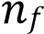=∞). At an infinite distance, the electron is no longer bound to the nucleus, and its energy is considered to be zero.
- Calculation: The ionisation energy (IE) is the minimum energy required to achieve this state. It is calculated as the difference between the energy of the electron in the initial orbit and the energy at infinity. o The energy of an electron in a specific energy level () of a hydrogen-like atom (one electron system) is given by the Bohr formula:
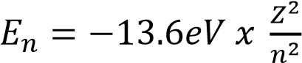 where Z is atomic number and n the principal quantum
number o For ionization, the energy change is
E = 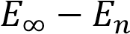
Since 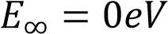, the ionisation energy from a given level is the positive value of 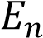
i.e 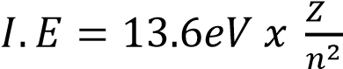

Example 9
(Hydrogen): For a hydrogen atom (=1) in its ground state (=1) the ionisation energy is:
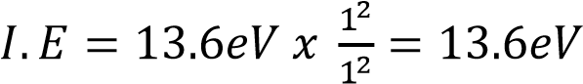 /atom

Example 10
Some of the energy levels of mercury are shown in the diagram below. Level 1 is the ground state level occupied by the electrons in an unexcited atom

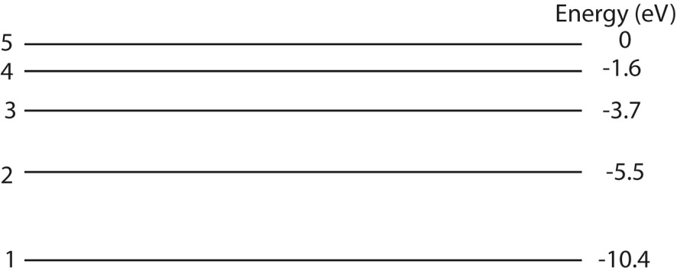
(i) Calculate the ionization energy of mercury atom in Joules
Ionization energy = 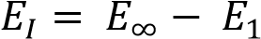
= 0 – (-10.4)
= 10.4eV
= 10.4 x 1.6 x 10⁻¹⁹

= 1.66 x 10⁻¹⁸J

(ii) (ii) Calculate the wavelength of the radiation emitted when an electron moves from level 4 to level 2.
Solution
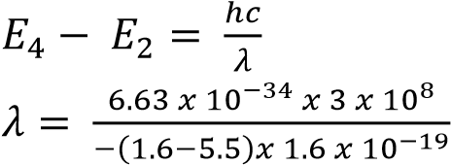= 3.2 x 10⁻⁷m
X-Rays
X- Rays are electromagnetic radiations of short wavelength produced when fast moving electrons are stopped by heavy metal target.
Production of X – Rays
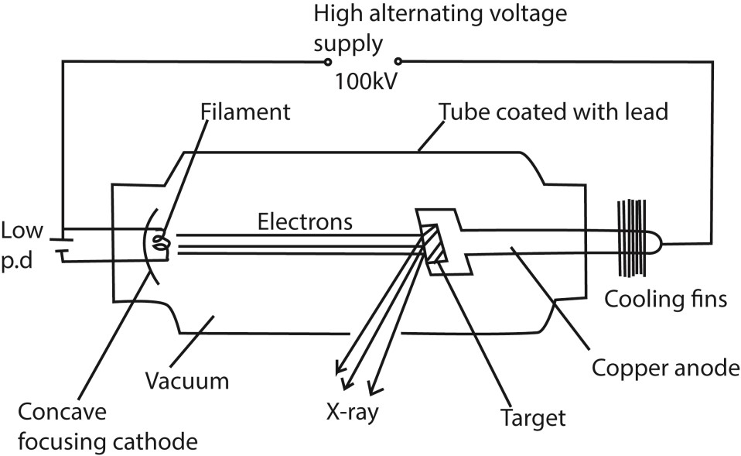

Mode of operation
- The filament is heated by a low voltage supply and the electrons are emitted by thermionic emission.
- The concave focusing cathode focuses the electrons from the filament onto the target.
- These electrons are accelerated towards the anode by the high voltage between the filament and the Anode.
- When the electrons (cathode rays) strike the metal target, about only 1% their kinetic energy is converted to X-rays and the 99% of their kinetic energy is converted to heat, which is conducted away by the cooling fins.
Note.
- The target is made of a high melting point metal.
- ii) The X-ray tube is covered by a lead shield with a small window for the X-rays to prevent the leakage of the X-rays.

Intensity of X-rays (Quantity or number of X-rays)
- The intensity of X- rays in an X – ray tube is proportional to the number of electrons colliding with the target.
- The number of electrons produced at the cathode depends on the filament current supply.
- The greater the heating current, the greater the number of electrons produced and hence more x- rays are produced.
- Therefore the intensity of X- rays is controlled by the filament current.

Penetration of X – rays (quality)
- Penetration power of X-rays depends on the kinetic energy of the electrons striking the target.
- The higher the accelerating voltage, the faster the electrons produced.
- Faster electrons possess higher kinetic energy and shorter wavelength x-rays of greater penetration power are produced.
- Hence penetrating power of X-rays is determined by the accelerating Voltage across the tube.

Types of X-rays
There are two types of X-rays, namely: Hard X-rays and soft X- rays
Hard X-rays:
- They are produced when a high p.d is applied across the tube.
- They have very short wave lengths
- They have a high penetrating power. This is because they have very short wavelengths
Soft X-rays:
- They are produced by electrons moving at relatively lower velocities than those produced by hard X –rays.
- They have longer wavelengths.
- They have a low penetration power compared to hard x-rays. This is because of their long wavelengths
Note:
- Hard X-rays can penetrate flesh but are absorbed by bones, they are therefore used to study bone fractures.
- Soft X-rays are used to show malignant growths since they only penetrate soft flesh. They are absorbed by such growths.

Properties of X –rays
- They travel in a straight line at a speed of light in vacuum
- They are not deflected by both magnetic and electric fields. This indicates that they carry no charge.
- They penetrate all matter to some extent. Penetration is least in materials with high density and atomic number e.g. lead.
- They ionize gases through which they pass.
- They affect photographic plates.
- They cause fluorescence in some materials.
- They cause photoelectric emission
- They are diffracted by crystals leading to an interference pattern.

Uses of X-rays
- Structural analysis, stresses, fractures in solids, castings and welded joints can be analyzed by examining X-ray photograph.
- Crystallography; Orientation and identification of minerals by analysis of diffraction patterns using Bragg’s law.
- Medical uses;
  - Analytical uses. These include location of fractures, cancer and tumor/defective tissue absorbs x-rays differently from normal tissue.
  - Therapeutics use for destroying cancerous cells and tumors. 4. Detection of fire arms at international airports
Health hazards caused by x-rays:
  - Destroy living cells in our bodies especially hard X-rays.
  - Cause Gene mutation (genetic changes in our bodies).
-

NOTE: It’s highly important to remember that each time you are exposed to X-rays, your health is also at risk yet we cannot live without them

Safety precautions:
  - Avoid unnecessary exposure to X-rays.
  - When exposure is necessary, keep it as short as possible.
  - X-ray beams should ONLY be restricted to the body part being investigated.
  - A worker should wear a shielding jacket with a layer of Lead.
  - Exposure should be avoided for unborn babies and very young children.

Example 11
In an X-ray tube, the current through the tube is0.1mA and accelerating p.d 1.5kV. Calculate the:
- The number of electrons striking the anode per second
I = ne where n is the number of electrons striking the anode per second
n = 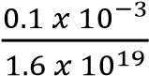 = 6.25 x 10¹⁴
- The speed of electron striking the anode
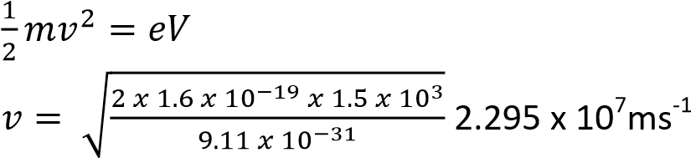
- The rate at which cooling fluid at 10⁰ must be circulated through the tube if the anode is to be maintained at 35⁰C.
[Assume all electrical energy is converted into heat energy and S.H.C of fluid is 2000Jkg⁻¹K⁻¹]

IVt = mc (θ₂ –θ₁)
IV = 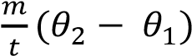
= KC(θ₂ –θ₁) where K is the rate of flow
K = 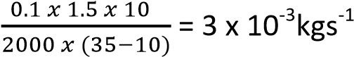

Example 12
In an X-ray tube, 90% of the electrical power supplied is dissipated as heat. If the accelerating potential difference across the tube is 75kV and 742.5W is dissipated as heat, calculate the:
- Current in the tube
P = IV; V = 75kV
90% of IV= heat lost
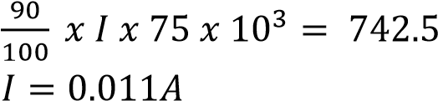

- Number of electrons arriving at the target per second I = ne where n is the number of electrons per second
n = 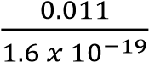 = 6.875 x 1016

Example 13
The current in a water-cooled X-ray tube operating at 60kV is 30mA. 99% of the energy supplied to the tube is converted into heat which is removed by water at a rate of 0.06kgs⁻¹. Calculate the: (i) Number of electron hitting the target per second
Number of electrons per second = 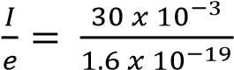 = 1.875 x 10¹⁷electrons per second
- Rate at which energy is being supplied to the tube
Power = IV = 30 x 10⁻³ x 60 x 10³ = 1800W
- Rate of change in temperature of cooling water 99%IV = heat lost per second
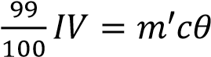 where m’ is rate of flow kgs⁻¹
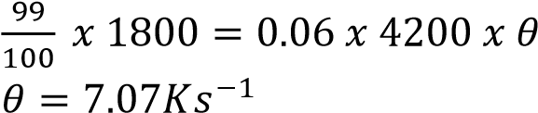

X-ray diffraction
The wave nature of X-rays can be confirmed by their diffraction with crystals Laue’s experiment:
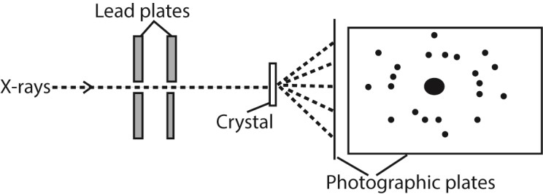
  - After long exposure of the crystal to the x-rays, the photographic plate is developed and printed.
  - A regular pattern of dark sports called Laue spots is observed around a central dark image.
  - The pattern is due to the X-rays which have been scattered by interaction of the X-rays with the electrons in the atoms of the crystal.
  - The regularity of the Laue spots implies that the atoms in a crystal are arranged in a regular pattern.

Bragg’s law
- A parallel beam of monochromatic X-rays incident on a crystal is reflected from successive atomic planes and super-imposed, forming an interference pattern.
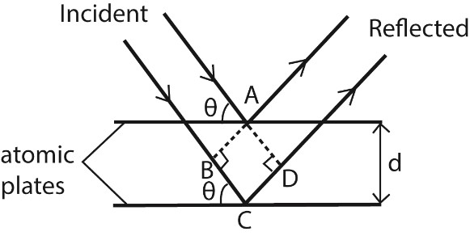
For constructive interference to occur, the path difference is equal to the whole number of wavelength Thus BC + CD = nλ
⇨ dsinθ + dsinθ = nλ or 2dsinθ = nλ where n = 1, 2, 3, 4 …

Example 22
A second order diffraction mage is obtained by reflection of X-rays at atomic planes of a crystal in sodium chloride at glancing angle of 11⁰. Calculate the atomic spacing of the planes if the wavelength of X-rays is 4 x 10⁻¹¹m.
From 2dsinθ = nλ
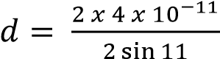= 2.096 x 10⁻¹⁰m

Example 14
X-ray of wavelength 1.55 x 10⁻¹⁰m are incident on a copper crystal of atomic spacing 4.25 x 10⁻¹⁰m
- Calculate the smallest angle at which radiation will be first reflected. From 2dsinθ = nλ
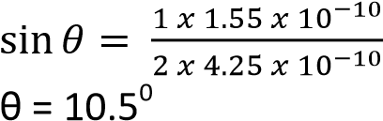
- If the temperature of the crystal is increased by 600⁰, calculate the change in the angle that will be obtained. [the coefficient of linear expansion of copper is 1.7 x 10⁻⁵K⁻¹]

From C_{θ}= C₀(1 + αθ)
d_{θ} = 4.25 x 10⁻¹⁰(1 + 1.7 x 10⁻⁵ x 600) = 4.29335 x 10⁻¹⁰m
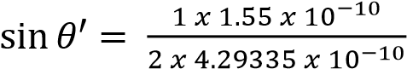
θ = 10.4⁰
change in angle = 10.5 – 10.4 = 0.1⁰

Example 15
A monochromatic beam of X-rays of wavelength 2 x 10⁻¹⁰m is incident on a set of cubic planes in potassium chloride crystal. First order diffraction is observed at glancing angle 18.5⁰.
Calculate
- The inter-atomic spacing on potassium chloride. From 2dsinθ = nλ
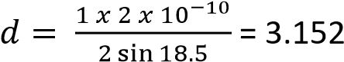 x 10⁻¹⁰m

- The density of potassium chloride if the RFM is 75.5grams
For the two ions in KCl
V = 2d³ = 2 x (3.152 x 10⁻¹⁰)³ = 6.263 x 10⁻²⁹m³
RFM KCl = 75.5
6.02 x 10²³ molecules of KCl weigh 75.5g
1 molecule weighs 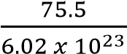 = 1.254 x 10⁻²²g
ρ = 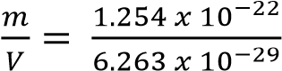 = 2002.2kgm⁻³.

X-rays Emission spectrum
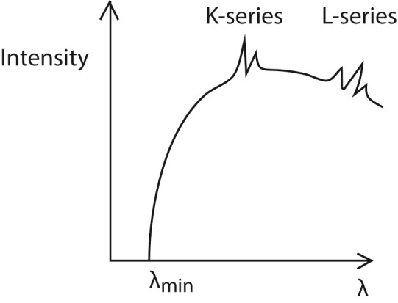
The spectrum consists of two major components, i.e. the continuous (background) spectrum and the very sharp line spectrum superimposed onto the background spectrum.
The continuous spectrum is produced when electrons make multiple collisions with the target atoms in which they are decelerated. At each deceleration, X-rays of differing wavelength are produced.

The shortest Wavelength X-rays are produced when electrons lose all their energy as X-ray photon in a single encounter with the target atoms. The wavelength of the X-rays at this point is known as the cut off wavelength. At cut off wavelength, energy in an X-ray photon equals kinetic energy of the electron; i.e. hf = eV or 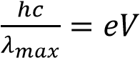 where V = p.d

The line spectrum
At high tube voltages, the bombarding electrons penetrate deep into the target atoms and knock out electrons from inner shell. The knocked out electrons occupy vacant spaces in higher unfilled shells putting the atom in excited state and making them unstable.
Transition of an electron from higher to lower energy levels results in an emission of X-ray photon of energy equal to energy difference between the energy levels.
If the transition ends in the K-shell, it produces K-series and if the transition ends in L-shell. It produces L-series.

TOPIC 3/3: NUCLEAR PROCESSES
Competency: The learner appreciates that nuclear reactions involve high amounts of energy which can be both constructive and destructive.

Radioactivity
This is the spontaneous disintegration of unstable atoms with emission of particles like alpha, beta particles and gamma radiations.
The nuclei of some elements like uranium, thorium are unstable undergo radioactive decay in order to gain stability.
The three types of radiations can be identified by:
- Their different penetrating powers/abilities
- Their ionizing powers
- Their behavior in electric and magnetic fields.

Alpha – particles, 
- They are the least penetrating with a range of a few centimeters in air and can be stopped by paper.
- They produce intense ionization in any gases through which they pass.
- They are deflected by both electric and magnetic fields.
- Their direction and size of deflection suggests that:
i) They are positively charged ii) They are relatively heavier particles.
- Alpha particles are therefore a Helium nuclei containing 2 protons and 2 neutron

Beta – particles
- They are more penetrating than the alpha particles with a range of several centimeters in air and a few millimeters in aluminum.
- They are less ionizing than the alpha particles.
- They are more easily deflected than the alpha – particles, and their size and direction of deflection suggest that:
i) They are negatively charged ii) They have a very small mass

Gamma rays
- They are highly penetrating
- They ionize gases to a very small extent
- They are not deflected by both the magnetic and electric fields, indicating that they are uncharged.

Rules governing radioactivity
- When a radioactive substance decays by emission of alpha particle, its atomic number A reduces by 2 and it mass number Z reduces by 4
i.e. 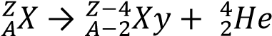
- When a radioactive substance decays by emission of beta particle, its atomic number A increases by 1 and it mass number Z remains constant
. 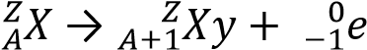
- When a radioactive substance decays by emission of gamma rays, both its atomic number A and it mass number Z remains constant
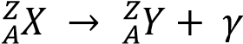

The decay law
It states that the rate of disintegration of the nuclei in a given time is propotional to the number of atoms present
Rate of decay,R = 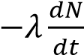
where N- number of atoms present, t = time, λ is a constant and negative because the number of atoms are reducing
The decay law can also be xpressed as N = N₀e^{-λt} where No is the intial number of disintegrating atoms.
The decay constant is the fractional number of atoms that are disintegrating per second
Half-life (t_{½}) is the time taken for the number of atoms in a radioactive element to reduce to half the original value.
From N = N₀e^{-λt}
In 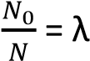t
At t = t ½ ; N = 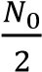
- In 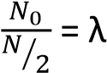t½
- t½ = 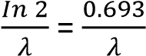
Activity is the rate of dsintegration of a radioactive substance = λN

Example 1
A sample of radioactive material initially contains 10¹⁸ atoms. If the half-life of the material is 2 days, calculate the
- number of atoms remaining after 5days
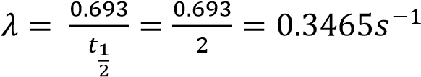
N = 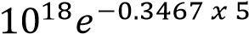 = 1.7684 x 10¹⁷

- percentage that decayed after 5days Number of decayed atoms = N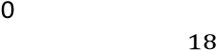 – N
Percentage decayed = 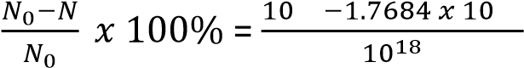x100% = 82.32%
- activity of the sample after 5days
Activity, A = λN = 0.3465 x 1.7684 x 10¹⁷ = 6.127506 cx 10¹⁶

Radioactive detector

A. Geiger Muller Tube (GMT)
The GMT is used to detect the presence of X- rays, Gamma rays, beta particles and if the window of the tube used is very thin, it detects even alpha particles.

Structure
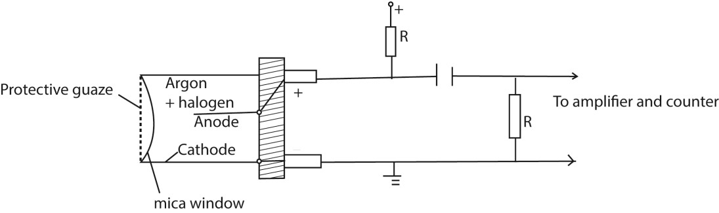
The thin mica window allows the passage and detection of the weak penetrating alpha particles. The GM tube is first evacuated then filled with Neon, Argon plus Halogen gas which is used as a quenching agent.
Mode of operation
Mode of operation
- When an ionizing particle enters the tube through the window, argon atoms are ionized.
- The electrons move to the anode while the positive ions drift to the cathode.
- A discharge occurs and the current flows in the external circuit.
- A p.d is obtained across a large resistance, R which is amplified and passed to the scale.
- The magnitude of the pulse registered gives the extent to which ionization occurred.
Note:
- The anode wire must be very thin so that the charge on it produces an intense electric field close to its surface.
- This electric field is used to accelerate the electrons towards it from the cathode.

Characteristics of a GMT
The graph below is obtained when the counter rate is plotted against the operating voltage.
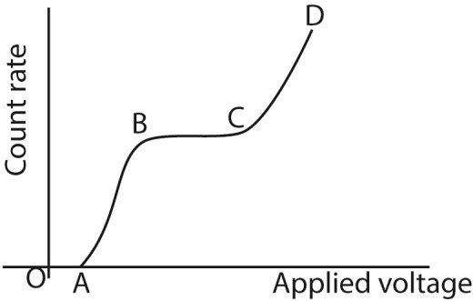
OA – the operating voltage is not enough to attract the ions to the respective electrodes and hence the counter registers no reading. This voltage (i.e. at A) is called the threshold voltage.
AB – the applied p.d not enough to attract all electrons; hence increasing the p.d increases the number of electrons being attracted and hence increase in counter rate.
BC – here the count rate is constant. This is called the plateau region.
- Between BC, all the negative ions are able to reach the anode because the operating voltage is large enough to attract them.
- Full avalanche is obtained along the entire length of the anode.
- Here the tube is said to be operating normally.
CD: - The count rate increases rapidly because the quenching process becomes ineffective and eventually a continuous discharge occurs which might damage the tube.
Definitions.
Dead time. This is the time taken by the positive ions to move from the anode to the cathode. During this time the tube is insensitive to the arrival of further ionizing particles.
Recovery time. This is the second period of insensitivity. During this period, pulses are produced but not large enough to be detected. In this time, argon ions are being neutralized by the quenching gas before they reach the anode.
Threshold voltage is the voltage below which there is no sufficient gas amplification to produce pulse high enough to be detected

Experiment to determine a half-life of radioactive substance using GM- tube
- Switch on the GM-tube, note and record the background count rate, A.
- Place a source of ionizing radiation near the GM-window.
- Note and record the count rate recorded the count rate at equal intervals.
- For each count rate recorded subtract the background count rate to get the true rate. - Plot a graph of the count rate against time.
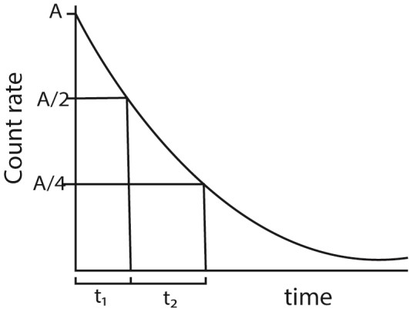

Find time t₁ taken for the activity to reduce to A/2 and t₂ taken for activity to reduce to A/4 from A/2
Half-life = 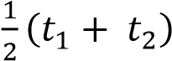

B. The diffusion cloud chamber

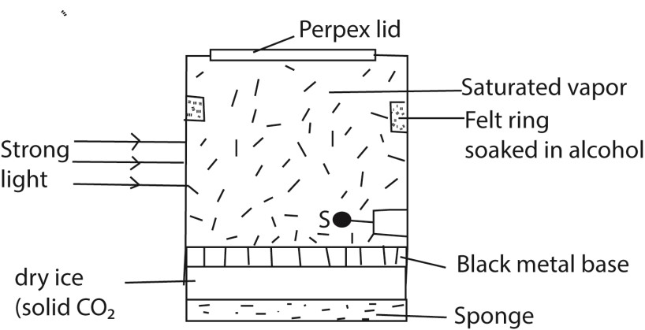
- The base of the chamber is maintained at low temperature, about -80⁰c by the solid carbon dioxide while the top of the chamber is at room temperature, and so there is a temperature gradient between the top and the bottom of the chamber.
- The air at the top of the chamber is saturated with alcohol vapor from the felt ring. This vapor continuously diffuse downwards into the cooler regions so that the air at the chamber is super saturated with alcohol vapor.
- Radiations from the radioactive source S cause the ionization of the vapor.
- The ionizations from the radioactive source S cause condensation of the vapor on the ions formed, hence the path of the ionizing radiations are traced by series of small droplets of condensation.
- The thickness and length of the path indicate the extent to which ionization has taken place.
- Alpha particles produce short, thick, continuous straight tracks
- Beta particles which are less massive produce longer, thin but straggly paths owing to collisions with gas molecules
- Gamma radiations are uncharged and for ionization to take place, it must collide with an atom and eject an electron which then ionizes the vapor.
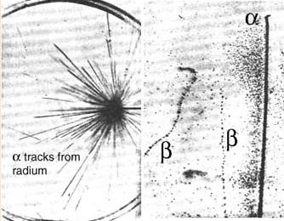

C. The Wilson cloud chamber
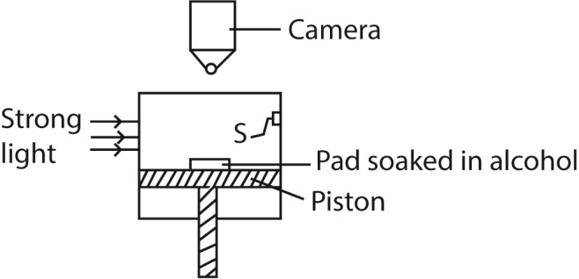

Mode of action
When the piston is quickly moved, the air in the chamber is saturated with alcohol vapour undergoes an adiabatic expansion and it cools.
The dust particles are carried away leaving behind air which is dust free. This is the subjected to controlled expansion making it super saturated.
It is then simultaneously subjected to ionizing radiation from a source, S. the vapour condenses on the ions formed to form water droplets around the ions
These are then illuminated and photographed by the camera.
The nature of the path formed reveals the type of ionizing agent.

D. Ionizing Chamber
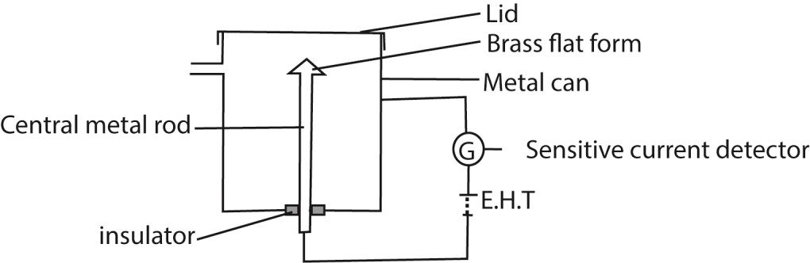
- A radiation source on the brass flat form causes ionization of air in the chamber producing electrons and positive ions.
- The electrons move to the metal can and positive ions drift to the central metal rod.
- Movement of the ions to the electrodes causes discharge and current pulse flows in external circuit.
- The current sensitive detector detects current.
- The magnitude of current detected shows the extent to which ionization takes place.
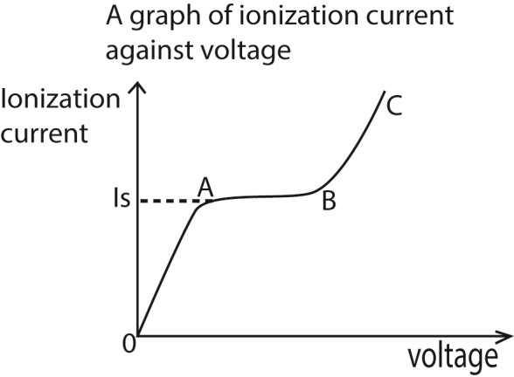
Region OA:
Current detected increases gradually but p.d is not large enough to prevent recombination of the ions.
Region AB. (saturation region)
Current is almost constant, all ions reach the electrode before recombination but there is no secondary ionization.
Region BC (gas amplification)
Current increases rapidly for small increase (change) in p.d because secondary ionization takes place due to primary ions being produced. This implies many ion pairs, thus a larger current detected.

Artificial radiations
These can be produced by
- Bombarding a nucleus of stable element with neutrons in a nuclear reactor
- Bombarding a nucleus of stable element with a charged particle such as alpha or beta particles.
Uses of Radioistopes and radioactivity

In industry
- Sterilization of food
- Detecting leakages in pipes
- Determining thickness of paper - Determining the rate of wear

In medicine
- Treatment of cance
- Tracer of disease
- Sterilizing medical equipment

Health hazards
- May cause cancers
- Eye damage - Cause sterility
- Cause mutation

Unified Atomic Mass unit U
Definition: the Unified Atomic Mass Unit (U) is one – twelfth the mass of one atom of carbon – 12 (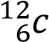) Derivation
1mole of a substance contains 6.02 x 10²³atoms
12g of carbon-12 contains 6.02 x 10²³ atoms
Mass of 1 atom of carbon-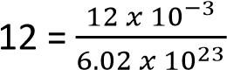 kg
= 12U
1U = 1.66 x 10⁻²⁷kg
But 1 kg change in mass produces 9 x 10¹⁶ joules and 1 Mev = 1.6 x 10⁻¹³joules
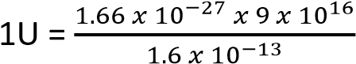= 931MeV

Binding energy (B)
The mass of the nucleus of atom is always less than the total mass of its constituent nucleons (protons and neutrons). The difference in mass is called the mass defect.
Mass defect = (mass of nucleons) - mass of the nucleons mass of the nucleus
The reduction in mass is because when the nucleons are combining to form the nucleus, some of the mass is released as energy in the form of gamma rays.
In order to break the nucleus and separate the nucleons, the same amount of energy which was released has to be supplied to the nucleus. This is called the Binding energy.
Definition:
Binding Energy is the minimum energy required to break the nucleus into its constituent particles and completely separate them from each other.
Binding energy = (mass defect in kg) X (speed of light)²

Example 2
The mass of lithium 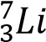 is 7.01818U. Calculate
(i) The binding energy of lithium atom

Solution
Number of protons = 3
Number of neutrons = 7-3 = 4
Mass of nucleons = (3 x 1.0081 + 4 x 1.009) = 7.067U
Mass defect = mass of nucleons – mass of nucleus
= 7.060 – 7.01818
= 0.04252U
But 1U= 931eV
Binding energy = 0.04252 x 931 = 39.58612eV

(ii) The binding energy per nucleon of lithium atom
Given mass of proton = 1.0081U
Mass of neutron = 1.009U
Mass of electron = 0.00055U
1U = 931eV
Binding energy per nucleon = 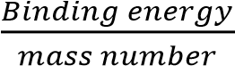
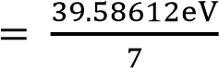
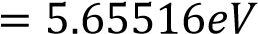

Example 3

Given that the mass of 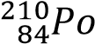 = 209.992U, 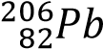 = 205.964U, 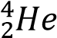 = 4.02U and 1U = 931eV;
- State whether it is possible for 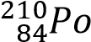 to undergo alpha decay.
→ 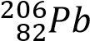 + 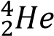
Total mass on RHS = 203.964 + 4.02 = 209.984U
Since there is a loss in mass, the reaction is possible and the loss in mass in mass is the energy released.
- Calculate the mass defect of the reaction
Mass defect (loss in ass = 209.992 – 209.984 = 0.008U
- Find the total energy released in the above reaction
0.008U = 0.008 x 931MeV =7.448MeV

Example 4
When a fast moving neutron hits uranium, 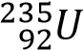 the nucleus breaks up into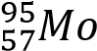,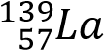, 2neutrons and
7electrons.
Calculate the energy released by 10grams of uranium in the reaction
[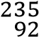 = 235.044U, = 94.906U, 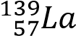 = 138.906U, 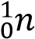 = 1.009U, 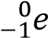 = 0.005U, 1U = 1.66 x 10-
27kgJ]
Solution

Mass defect = (235.044 + 1.009) – (94.906 + 138.906 + 2 x 1.009 + 7 x 0.005)
= 0.188U
= 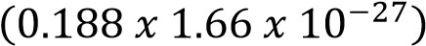kg
= 3.1208 x 10⁻²⁸kg
From E = mc²
Energy released = 3.1208 x 10⁻²⁸ x (3 x 10⁸)²
= 2.81 x 10⁻¹¹J
1mole mole 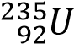 contains 6.02 x 10²³ atoms 235g contain 6.02 x 10²³ atoms
10g contain 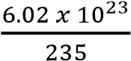 = 2.562 x 10²² atoms
But 1 atom releases 2.81 x 10⁻¹¹J
2.562 x 10²² atoms release 2.81 x 10⁻¹¹ x 2.562 x 10²² = 7.1992 x 10¹¹J

Example 5
Given that 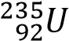 = 238.12492U, 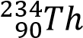 = 234.1165U, 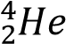 = 4.0038U, 1U = 933MeV
- Show that the nucleus of uranium can disintegrate by releasing an alpha particle
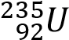 → 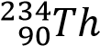 +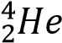
Total energy on the RHS = 234.1165 + 4.0038 = 238 .1203U
Since there is a loss in mass, the reaction is possible and the loss in mass in mass is the energy released.
- Calculate the energy released in the process
Energy released = 238.12492 - 238 .1203
= 0.00462U
=0.00462 x 933MeV
= 4.31046MeV
- Calculate the kinetic energy gained by the alpha particle. Let Q = total energy released
Q = K.E_{Th} + K.E_{α}
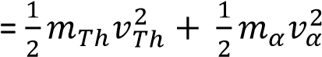 ……………………………… (i)
From conservation of momentum
Initial momentum = final momentum
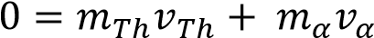
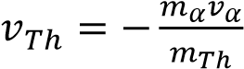 …………………………………………………. (ii)
Substitute Eqn. (ii) into Eqn. (i)
Q = 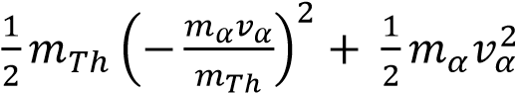
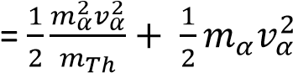
Factorize 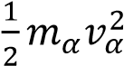
Q = 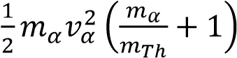
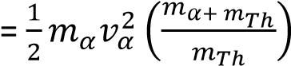
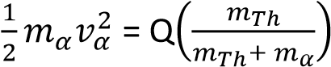
Kinetic energy gained by alpha particle
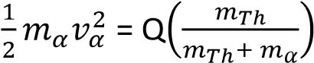
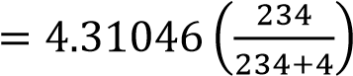


Nuclear stability
The nuclear stability depends on the number of neutrons and protons present in a nucleus.
Stability of light nucleus is most likely when number of protons = number of neutrons, e.g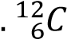,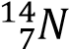…
Stability of heavy nuclei is most likely to occur when the nucleus has more neutrons than protons, e.g.
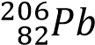.
A graph of the number of neutrons against the number of protons to show the stability zone
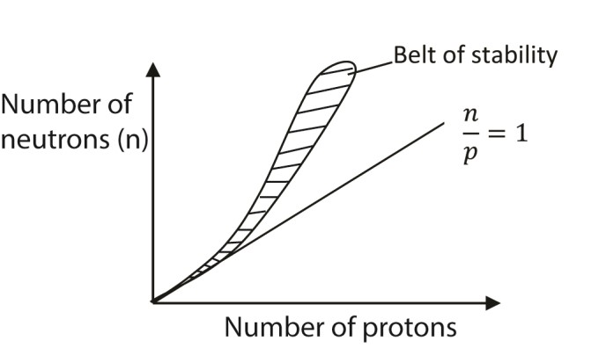
Unstable isotope are found below and above the stability belt. Disintegration produces new isotopes which are closer to stability belt than the original isotopes

Mode of decay
- the nuclei above the belt of stability are rich in neutrons and hence disintegrate in such a way that one of the neutron is converted to a proton
i.e. 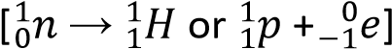 or such nuclei emit a β-particle.

Example
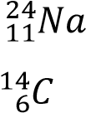
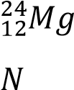
  - → + 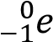
  - → 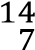 +

- The nuclei lying below the belt of stability are deficient in neutrons and hence disintegrate in such a way that one of their proton is converted into a neutron. The conversion can be done by any of the following two ways (a) emission of positron: 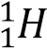 → + 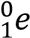 (b) electron capture process
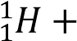 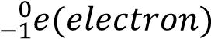 → 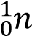

- 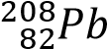 and 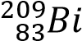 are the heaviest stable nuclei. Nuclei having higher number of protons or neutrons disintegrate by loss of α (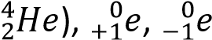 or by fission process.

The higher the binding energy the more stable the nucleus.
Binding energy per nucleon is the ratio of energy required to break a nucleus into free neutrons and protons to the mass number.
i.e. binding energy per nucleon = 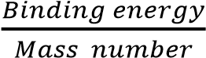

Nuclear fission
This is the splitting of a heavy nucleus into two or more light nuclei accompanied by the release of energy.
Sufficient excitation energy for the nucleus to split may be provided by particle bombardment of the nucleus with protons, neutrons or electrons. E.g.
+ energy

Neutrons are preferred as bombarding particles because they do not carry charge and therefore can penetrate deeper into the nucleus.

Uses of nuclear fission
- To provide electricity
- To manufacture atomic bombs.

Nuclear fusion
It is the union of two lighter nuclei to produce heavier nucleus of higher binding energy per nucleon accompanied by release of energy, e.g.
Nuclear fusion takes place at high temperature because the nuclei need a lot of kinetic energy to overcome their electrostatic repulsion.
A sketch of Variation of Binding energy per nucleon with mass number relating nuclear fusion and nuclear fission

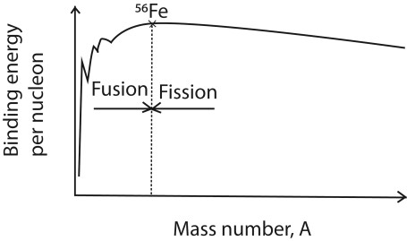
Note that:
- Two Small nuclei with atomic mass less than 56 each fuse to give a heavier nuclei with smaller mass by higher binding energy to increase stability of nucleon
- A nucleus with atomic mass higher than 56 split to form lighter nuclei of higher binding energy per nuclei.

